The Specialty electric door mechanisms (DM1-100, DM1-101, DM1-200, DM1-201, DM1-207 & DM1-400) are lubricated during assembly at our North Carolina facility. The bushing on the gear is oil-impregnated. Units should be inspected semiannually for ease of movement and if gear teeth are dry.

To lubricate apply a general purpose lithium based grease liberally to the gear teeth on the large gear and motor-pinion gear. This should be NLGI grade # 1.5 to 2 (ex: Sta-Lube #SL3310 or Mobiltemp SHC32 or equivalent). Apply a SAE Grade 20 oil similar to Mobil Almo 525 (or equivalent) to the gear shaft at the top & bottom of gear as shown in picture below.

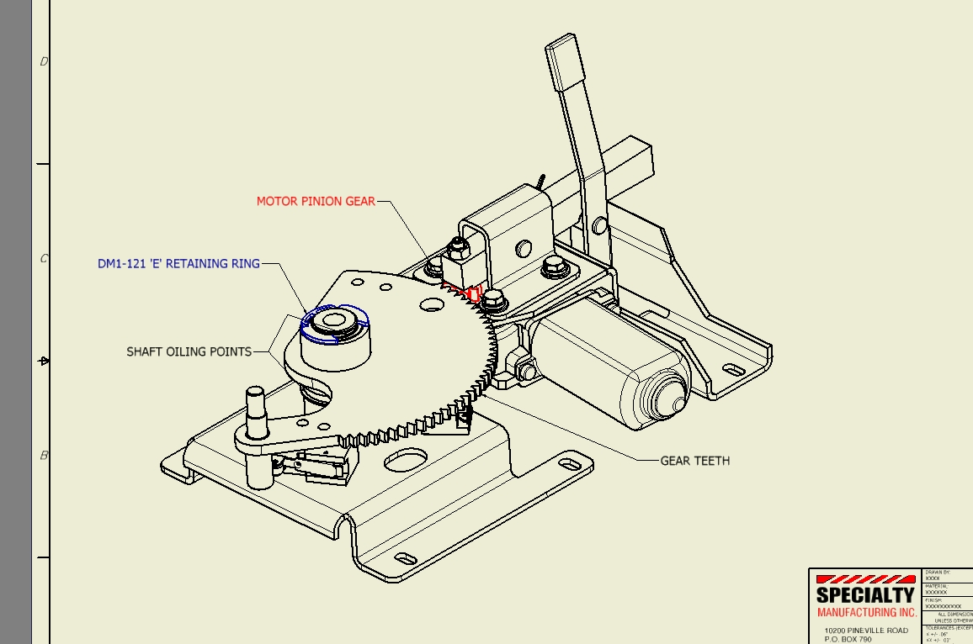

To adjust the micro-switches on the mechanism please refer to Technical Bulletin #A503. <http://www.smiglobal.net/tech_bulletins.php>