All Transpec hatches will be shipped with black Handle Shield rivets (p/n #T2113). These nylon rivets will replace the current clear polycarbonate T2112 rivets. The black rivets provide two significant improvements over the current clear rivets.

First, if work currently is to be done on a handle component, the clear rivets must be drilled through in order to remove the handle shield. Unfortunately, there are times when drilling the rivet may cause a piece of the rivet to fall inside the hollow lid. This could result in a rattle during operation. The new black rivets feature a threaded pin which is driven into place, but can be unthreaded with a Phillips Head screwdriver. This feature eliminates the need to destroy the rivet to remove the Handle Shield.

Second, the clear rivets are produced with separate prongs in polycarbonate. The black rivet is a one piece rivet body produced in a nylon resin. This material choice and design lends itself to reducing the possibility of a fragment becoming caught inside the lid.

Additionally, the black appearance complements the black items that currently exist on the hatch (i.e. link & plunger assembly, shoulder bolts, gasket, decals).

The black rivets will also be included in replacement kits for the handle components.

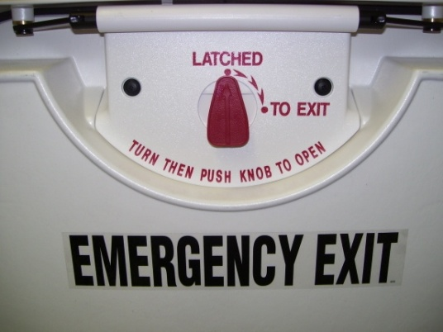

Current Rivet (inside view of lid)

New Rivet (inside view of lid)

