
Tools Needed:
5/64” Allen Wrench Electric Drill w/ 5/32” drill bit
Pliers Hammer
T-20 and T-40 Torx Drive

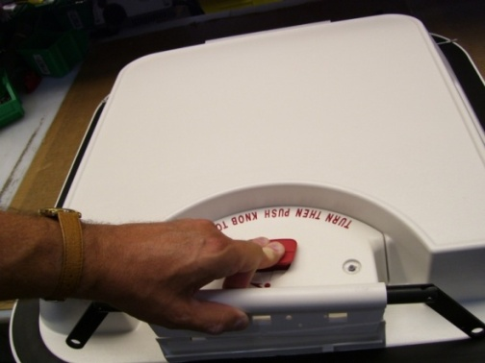
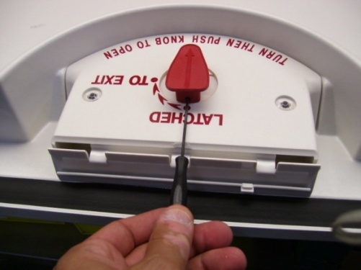

STEP 1. Remove the lid from the hatch frame (T-40 Torx drive). Place lid on a flat surface with the inside of the lid facing upward. Depress the inside red knob to remove release hinge.
STEP 2. Orient the inner red knob as shown. Remove set screw in knob using 5/32” allen wrench.

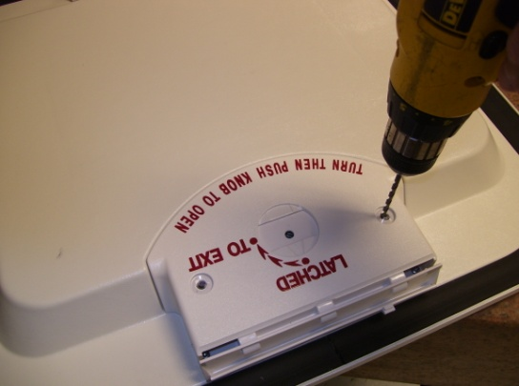
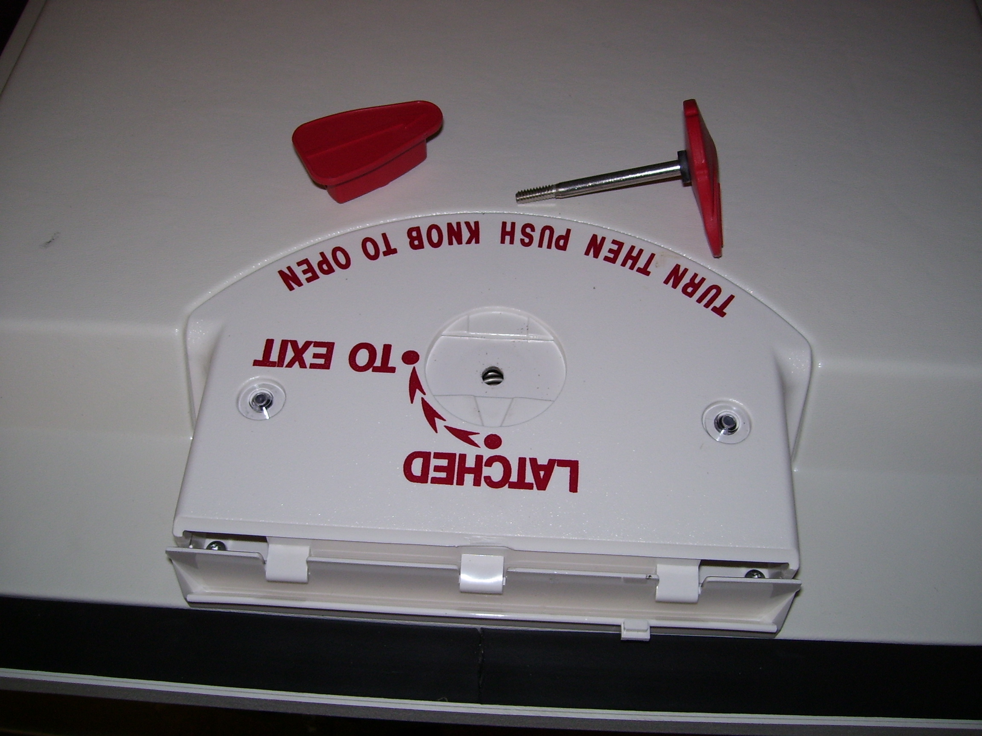

STEP 3. Unscrew the inner red knob from the outer red knob. Remove each from the lid.
STEP 4. Using a 5/32” drill bit, carefully drill through the center of the plastic rivet. Remove both rivets.

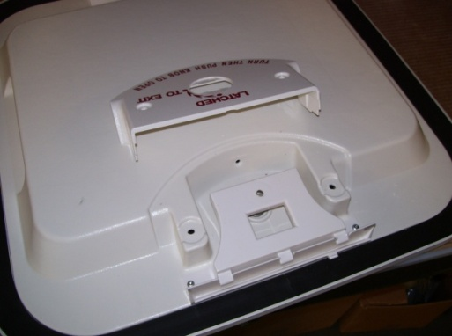
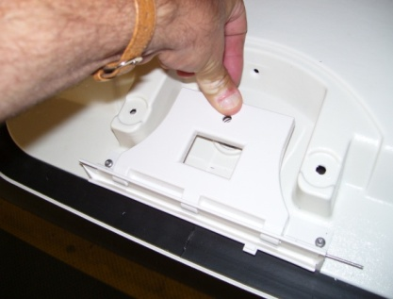

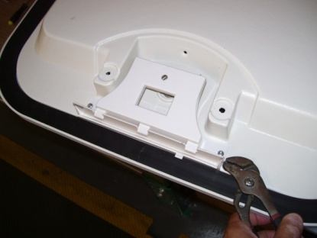

STEP 5. Remove the handle shield.
STEP 6. Remove the hinge pin from the side of the handle base. Pushing on the handle makes it easier to remove the pin. Caution: gloves are recommended for this step as plastic edges can be sharp.

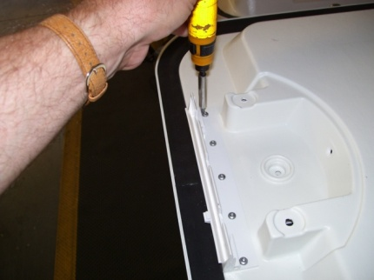
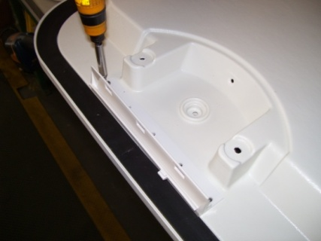

STEP 7. Using a T-20 Torx bit, remove the 5 screws that hold the handle base to the lid.
STEP 8. Using the same screws, attach the new handle base to the lid.

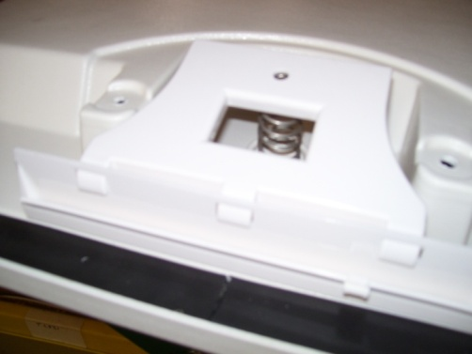
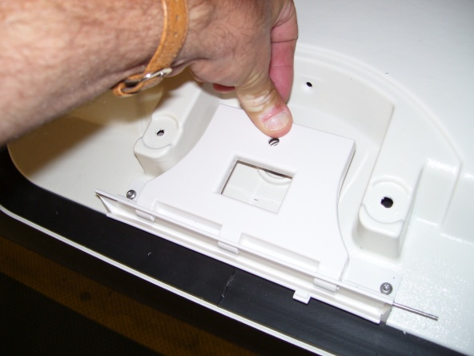

STEP 9. Place the new handle/spring on the lid. Ensure that the handle hooks are in the openings of the handle base (3 places).
STEP 10. While pushing down on the handle, slide the hinge pin into the hole on the handle base. Pushing on the handle will help locate the pin during insertion. You will need to guide the pin into the second hole on the handle from underneath the handle. Lightly tap the pin with a hammer until the pin is fully inserted.

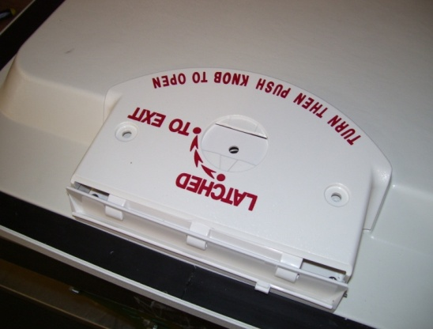
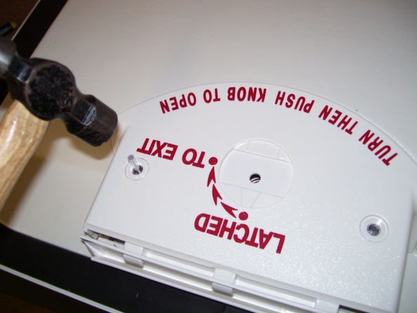

STEP 11. Place the handle shield back in position.
STEP 12. Hold the handle shield down against the lid. Insert the rivets into the holes in the shield and the holes in the lid. Lightly tap on the head of the rivets to set the rivets.

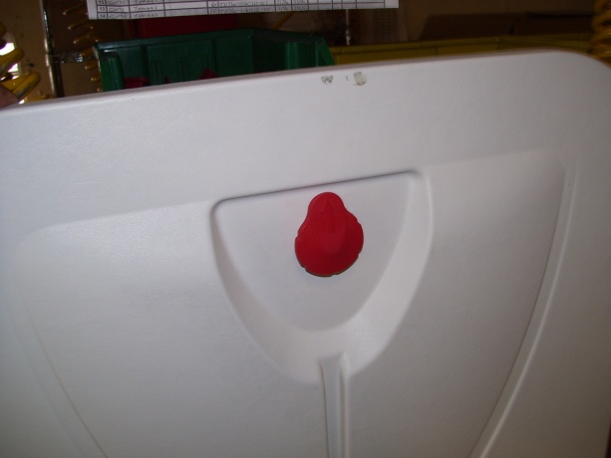
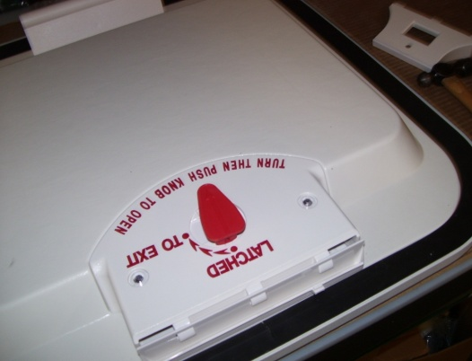

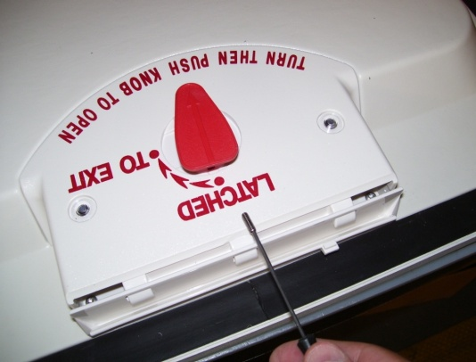
STEP 13. Orient the lid vertically as shown. Insert the shaft of the outer knob into the lid with the knob oriented as shown.
STEP 14. Holding the outer knob in the Step 13 orientation, thread the inner knob onto the shaft for a total of 8.5 rotations.
STEP 15. With the two knobs held in place as shown, secure the set screw in the inner knob. After tightening the set screw, rotate the knobs 180° until the inner knob’s arrow points to “LATCHED”.

REINSTALLING THE HATCH IN THE BUS

STEP 16. Reinstall a plunger spring into each end of the fixed hinge. Reinstall a link and follower assembly into each end of the fixed hinge.

STEP 17. Using two of the shoulder bolts included in the kit, reinstall the hatch lid onto the bus with the hatch oriented so that the fixed hinge is closest to the front of the bus. While holding the linkage against the head of the shoulder bolt to ensure proper alignment, torque the shoulder bolts to a range of 50-60 IN-LB.

STEP 18. If a release alarm is present: Remove the alarm from the original release hinge. Reattach the alarm to the new release hinge.

STEP 19. Reinstall a plunger spring into each end of the release hinge. Reinstall a link and follower assembly into each end of the release hinge.

STEP 20. Using two of the shoulder bolts included in the kit, reinstall the release hinge onto the bus with the alarm facing outward. While holding the linkage against the head of the shoulder bolt to ensure proper alignment, torque the shoulder bolts to a range of 50-60 IN-LB.

STEP 21. Secure the hatch lid and turn knob to “LATCHED” position.

If further help is needed, contact the engineering department at Specialty Manufacturing, Inc.
10200 Pineville Road Pineville, NC 28134
TEL (704) 889-7518 FAX (704) 889-2760
www.smiglobal.net

