The 005150-L module is used in some applications that do not use the strobe (+), purple lead, and the strobe (-), green lead. One of these applications is the 005155K, the retrofit kit for 5 series crossing arm. Another would be the 005151, kit-5.5 replacement module, for any stop arm with incandescent lights on the blade, basically most non-strobe light arms. For the above noted applications please insulate the strobe (+), purple lead, and the strobe (-), green lead shown in Figure 1 below.

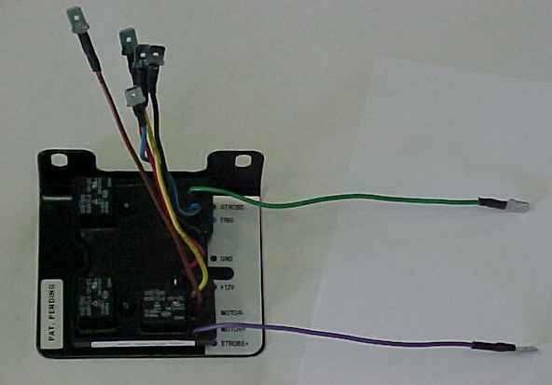
GREEN wire
Insulate both wires for non-strobe applications
PURPLE wire
Figure 1

For additional information, please contact the customer service department of Specialty Manufacturing, Inc. 1-800-951-7867.

