Effective 07/01/06, all 05057 hinge pins are manufactured from 304 stainless steel. The stainless steel hinge pin offers increased life and excellent wear resistance and may be identified by the nickel color as well as the lack of a top flange. The new design hinge pin is completely compatible with all previous 05057 applications, and requires no special tools or modifications to be used as a replacement part for older crossing arms. For additional information, please contact the customer service department of Specialty Manufacturing, Inc. 1-800-951-7867.

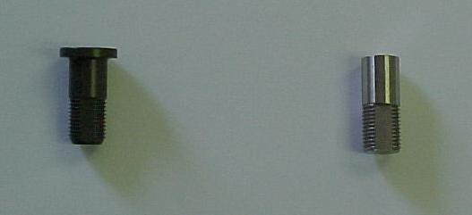
Previous hard-anodized hinge pin with flange.
Previous hard-anodized hinge pin with flange.
Stainless steel 005057 without flange .

