Tools needed:
5/16” socket and corresponding ratchet
7/16” socket
razor knife or equivalent
Flat head screwdriver

To replace the 5014 motor with the 5014 redesigned motor with built in bracket:
Replacement is as follows: (Pictures shown are for representative purposes only. Procedure is the same for either 5-series or 6-series- Stop Arm or Crossing Arm.)
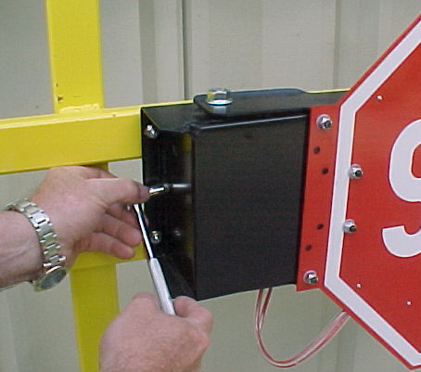
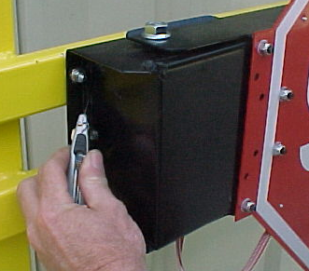
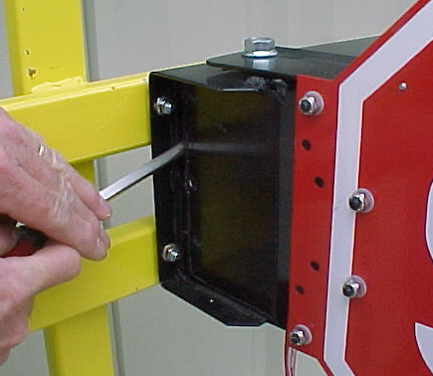
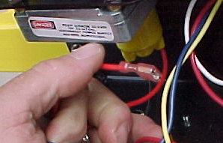

4. Unplug the red and black motor wires from the relays
(or from module- if 6-series)
2. Remove screws from both ends of the cover using 5/16” socket
1. Using a utility knife, cut the silicone seal on both ends of the stop arm cover.
3. Remove the cover by using a flat bladed screwdriver to pry it off.

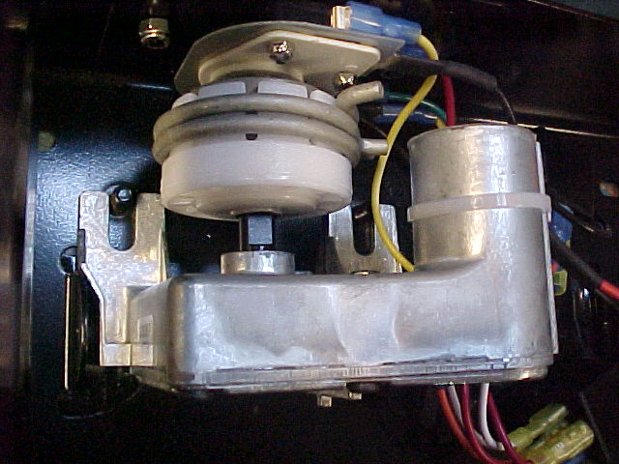
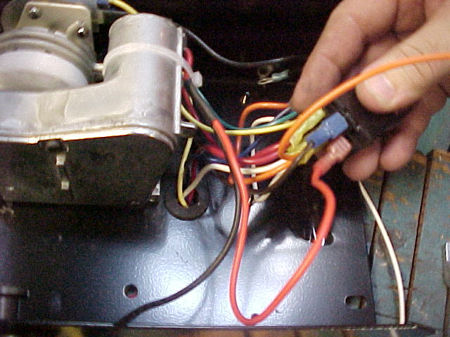

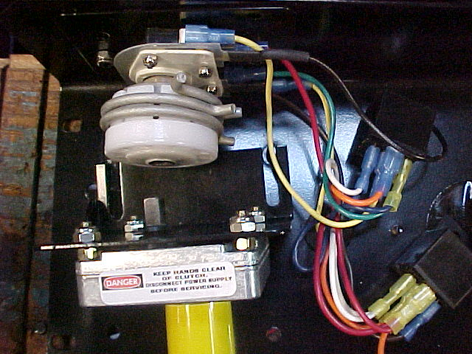

7. Reattach the red and black motor wires to the relays (or to module- if 6-series). The red wire attaches to the upper relay, the black to the lower.
5. Remove (2) each of washers, lock-washers and nuts on the motor bracket and remove both the motor and bracket from the assembly, using a 7/16” socket
6. Position flats of motor shaft so that they are parallel to the base, for ease of assembly- then push into place as shown above. Reattach (2) each of washers, lock-washers and nuts to secure new motor in place.

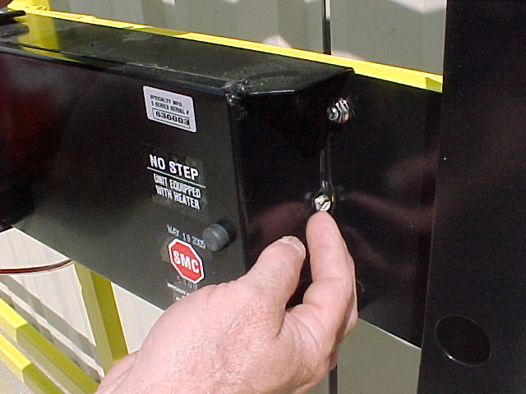
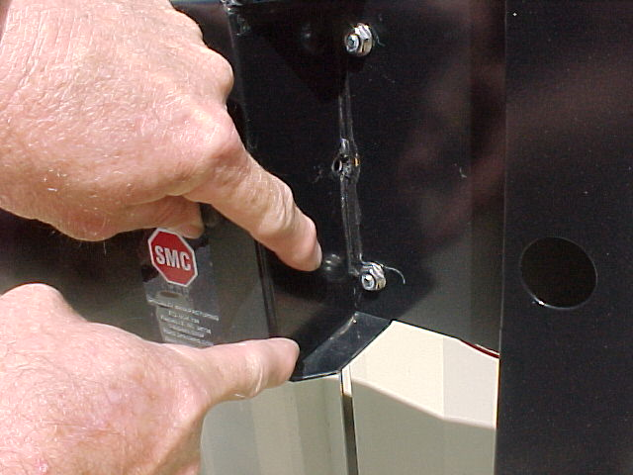
LEAVE THIS SECTION UNSEALED

8. Replace cover. Secure with (2) screws. Reseal both ends of the crossing arm cover with RTV. IMPORTANT! - DO NOT seal approximately 1” of the lower right side of the box. This provides an additional drainage location.
Test the assembly to make sure it functions correctly.

If further help is needed, contact the engineering department at Specialty Manufacturing.

