Currently, Specialty Manufacturing offers two different motors (p/n 005014 and 006014) for stop arm and crossing arm applications. Due to a recent redesign of the motor, which incorporated the mounting bracket into the motor gearbox case, identification of the two motors may not be readily apparent, nor are the design differences readily identifiable. To ensure that the proper motor is used for the correct application, please use the following guidelines for motor identification:

P/N 005014

- WHITE MOTOR ENDCAP
- BRONZE OUTPUT SHAFT BEARING
- RUBBER V-SEAL MOUNTED ONTO GEARBOX OUTPUT SHAFT

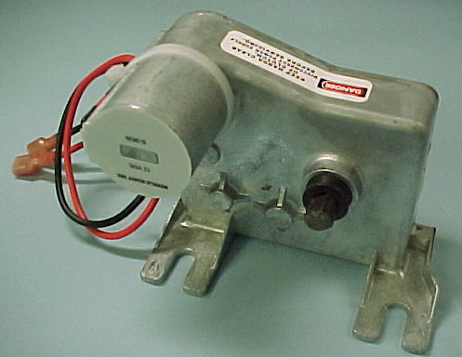
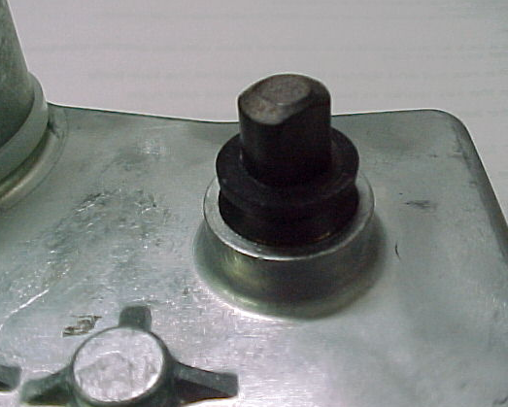
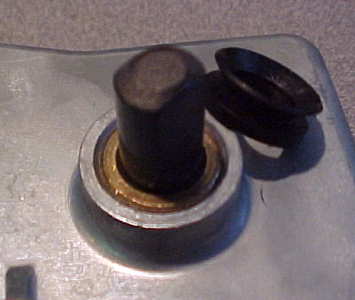

P/N 006014

- RED MOTOR ENDCAP
- NEEDLE BEARING OUTPUT SHAFT BEARING FOR HEAVY DUTY APPLICATIONS
- LIP TYPE SEAL PRESSED INTO GEARBOX CASE ON OUTPUT SHAFT
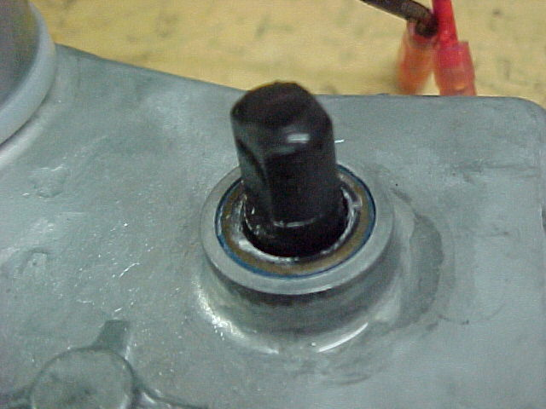
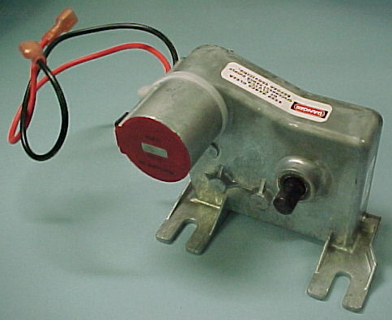

Please note that use of these motors as replacements for old non-integrated bracket motors will require the original mounting bracket to be discarded as the new style motors mount directly to the stop arm/crossing arm base. In some applications, the motor may not may to be a direct replacement. Please contact the sales department at Specialty Manufacturing Company for specific applications.

