Thank you for choosing Specialty LEDs for the added safety of your fleet. Once installed, the stop arm of your bus will attract motorist’s attention and stop traffic with high bright flash lighting combined with the many benefits of LED technology.

Your kit should contain:
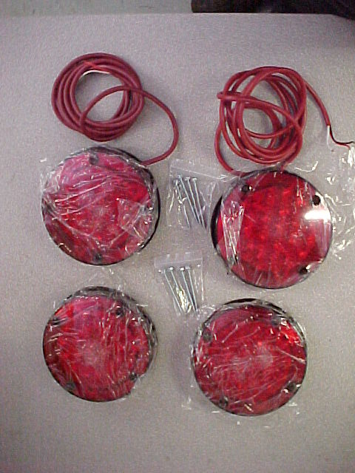
(1) (2) “Master” LED Lamp modules including 6ft of +/- 18AWG wire cable with red PVC jacket and 2 position connector on the back.(One master is the control master, and the other is the power master (the control master can be identified by the two wire loops on the back, brown, and blue.))
(2) (2) “Slave” LED Lamp modules and each with 2 pin connector.
(3) (8) Hex head flat blade screws

This LED upgrade is designed to replace 12Vdc incandescent lights on the
octagonal blade used with air, vacuum, and electric stop arms. Not for use
with a stop arm strobe power pack. For applications that are replacing
strobe lights, the strobe light power pack can be removed.

Removing your existing incandescent stop arm lights

STEP 1: Remove the existing lens, gasket, and #1156 bulb from it’s socket.
STEP 2: Remove the hex head screws from the incandescent bulb socket, and on the cable wire mounting clips freeing the old stop arm cable from the blade.
STEP 3: Once the socket and pigtail are unattached from the stop arm blade, cut the bulb socket and remove the old outer plastic wire protector if one is in place.
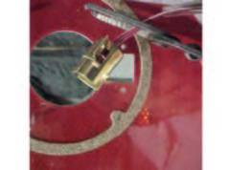

(DO NOT YET PULL THE EXISTING WIRE THROUGH THE CONTROL PANEL)

Installing your new 9000 series LED Stop Arm Upgrade Kit

The “control-master” LED Lamp, and the “power-master” master LED Lamp (both with 6 ft red jacket cable) contain the LED and power conditioning circuitry which produces the alerting flash along with the alternating lighting of the top and bottom lights. The LED lamp is initially configured to strobe, for a flashing LED lamp cut the brown wire in the back of the control master unit. Each master connects to it’s slave via the 2 position connector to control it’s light synchronzing with the master.

STEP 1: Firmly connect the ends of the new LED cable to the old wire or cable (left aside after cutting the old wire at the bulb socket) using well adhering tape such as duct tape. Make sure they are attached firmly to pull the new cable through the wire hole on the bottom of the stop arm base, into the control panel and/or location of the eight way flasher module. Pull the new cable completely through leaving 2 ft for mounting to the stop arm blade.
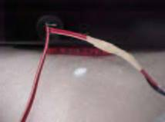
NOTE: Remember the “master” lights must mount on the inner side of the stop arm blade just like the original. (The master can also be identified as the lens in which screw head shows since it’s this side the screws are inserted to mount the assembly together.)

STEP 2 : Align the LED modules mounting holes to the four small round cut-out holes on the stop blade, front and back. Electrically connect the two sides (master and slave) of the light through the 2 pos. connector going through the big cut-out where the original incandescent bulb was mounted in the stop blade. Seat well and screw together firmly for a good water tight seal around the edge of the lens to protect the master/slave connector.
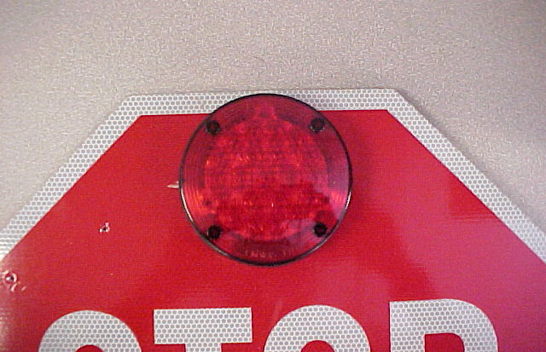
DO NOT OVER-TIGHTEN !

STEP 3 : Replace the plastic red wire clips
(removed earlier) along the new red jacket
cable which will now affix to the stop blade.
NOTE: Repeat this procedure for both the top
and bottom stop arm lights.

Wiring your new LED Lights to the bus 8-way flasher system:
Your new LED lights incorporate a “strobing” flash pattern (approx. 18Hz) as well as the circuitry which alternately lights the top and bottom (75 flashes each light per minute). The only connection on the bus required to allow the lights to work in sync with the eight way flasher system is the stop arm output terminal (located on the eight way flasher module) or it’s equivalent. Since this new stop arm LED light system uses about ¼ the current used by the incandescent light system it will not affect the 8-way flasher system adversely and, actually, it will help increase the life of the existing 8-way flasher.
With all the LED lens modules connected in place on the stop arm blade, align the two sets of red cables into the desired location in the bus control panel. Trim off any excess cable allowing enough to connect to the 8-way flasher, the two black wires connect to ground, the two red wires connect to the stop arm output terminal, and, the two white wires connect together.
Final test your new LED lights with the master switch on and the door opened for normal operation as the 8-way overhead red lights light. You should observe the standard alternating between top and bottom lights along with the “strobing” action of the LEDs as they light. You’ll see that the LEDs attract much more attention than the old system adding to the safety of students getting on and off the bus.

For technical assistance and customer service please call us at 1-800-951-7867

