Note: This module is a drop-in replacement for 5-series stop arm microswitch plate assembly for units with & without strobes. This is not a retrofit for any 6-series unit.
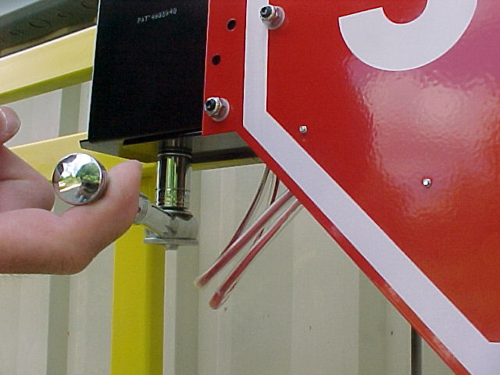
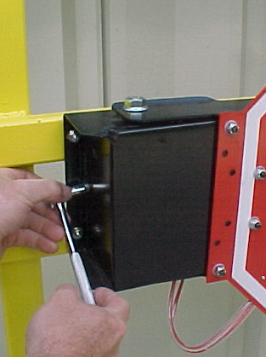
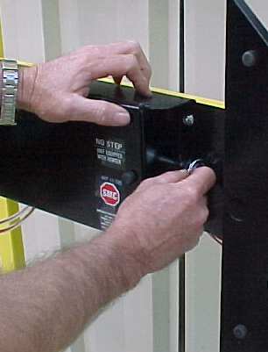
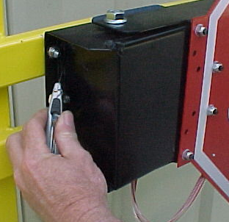
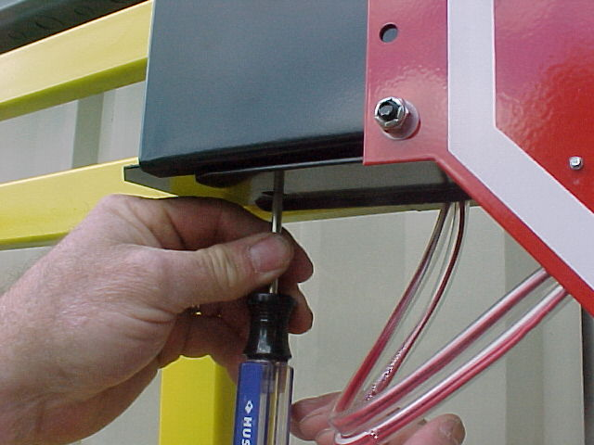

1. Remove ½-20 nut at the bottom of control box w/ ¾” wrench.
3. Cut silicone seal at both ends of the stop arm cover.
4. Remove screws from both ends of cover as shown, using a 5/16” socket.
2. Use a screwdriver (or similar tool) to tap the cam shaft up inside the unit.

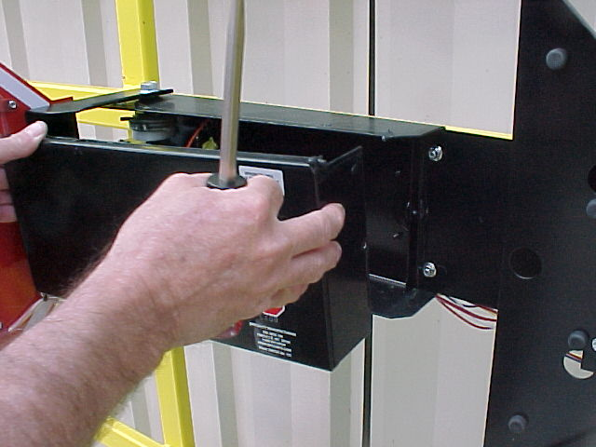
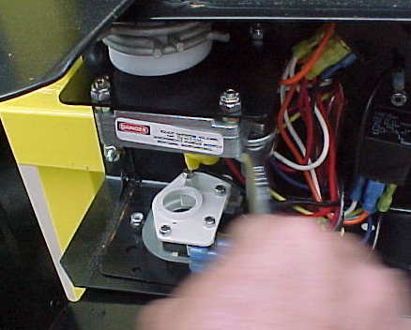
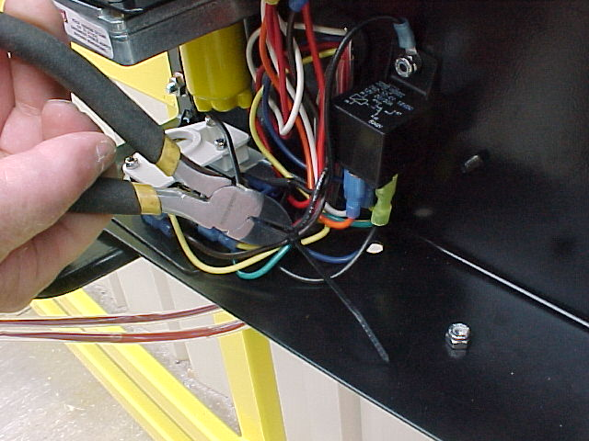
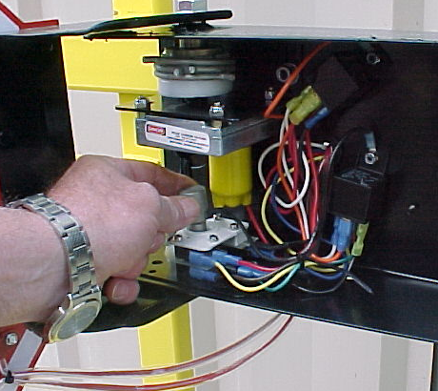

5. Rotate sign for access & remove cover.
7. Remove (2) 11/32” nuts holding microswitch plate. Assy will come out as one unit.
8. Carefully cut the wire tie
6. Remove camshaft and discard. It’s not needed w/5.5 series.

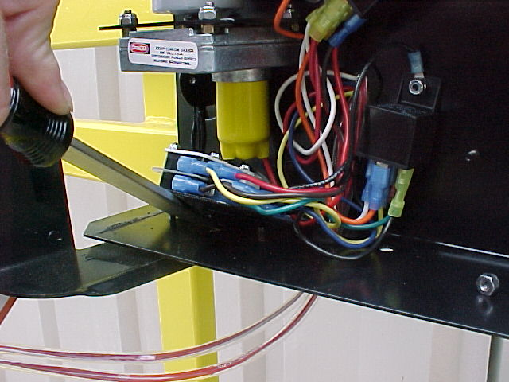
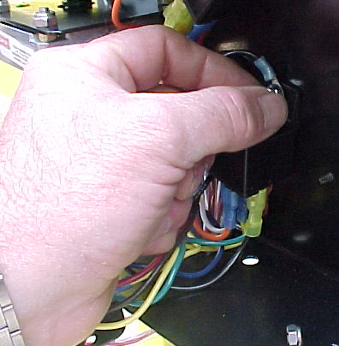
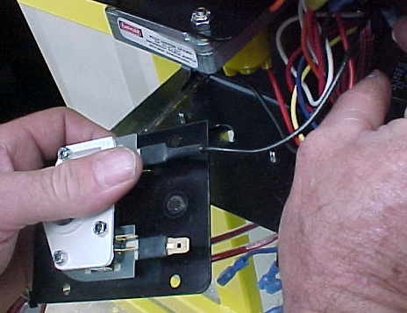

9. Pry microswitch plate up releasing snap ring & bushing. Caution-bushing may break & snap ring will make a loud noise when released. Discard ring & bushing.
10. Remove all wires from micro- switch plate assy. Black heater wire remains with assy.
11. Remove the 11/32”
nuts on both relays.

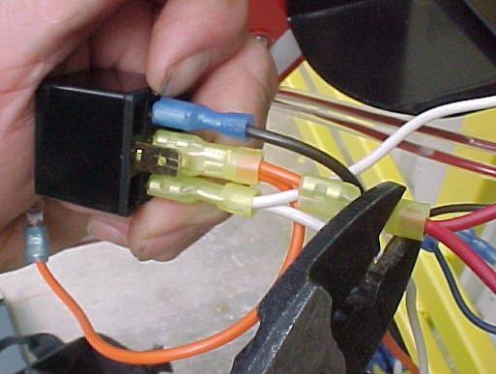
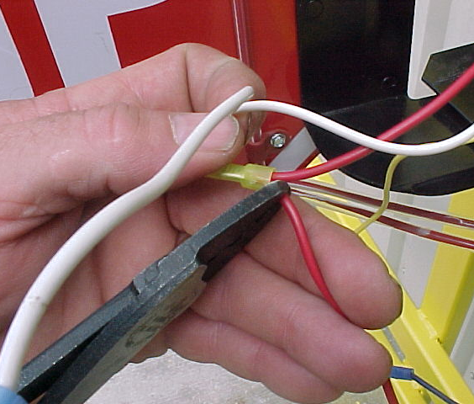
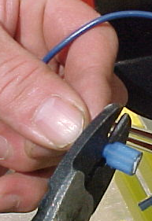

12. Disconnect wires from the relays. Discard relays, microswitch assy &
jumper wires- double orange, double
black/green, brown & yellow.
13. Cut smaller (shorter) wire from the double red & double white pigtail sets.
14. Cut Fast-On end off of BLUE wire, strip end approximately ¼” & crimp new ¼” fast-on blade, 004024, included with kit.

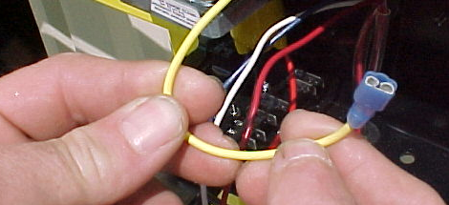
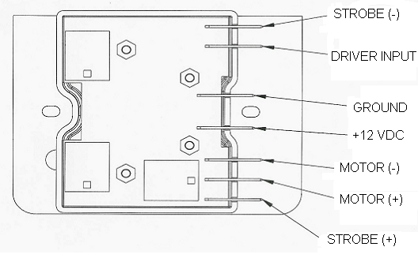
15. Connect leads to new 005150 module tabs as shown on schematic to left. Leave two center tabs, +12VDC & GROUND, disconnected until module is fastened down in next steps. The yellow wire is no longer needed and can be tied back.
RED
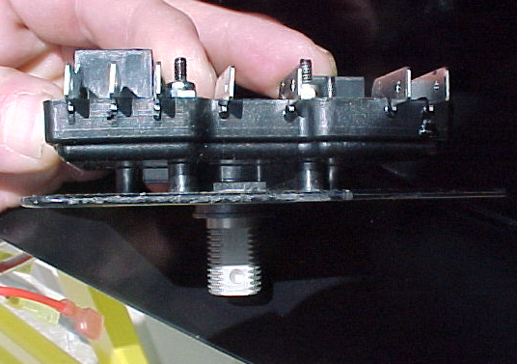
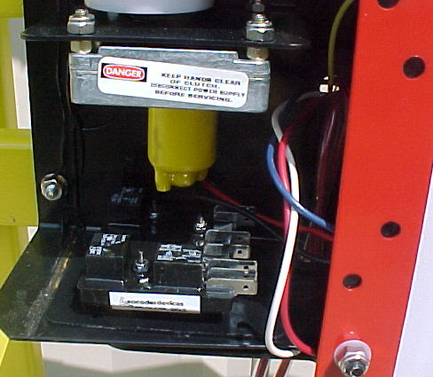
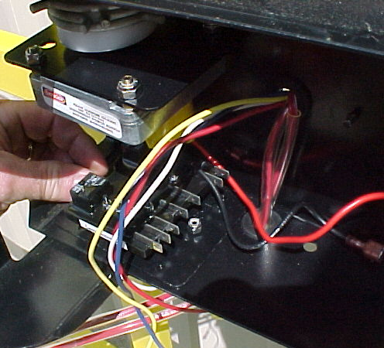

16. Install new 005150 module into position as shown above. Timing mark MUST be facing toward the direction of the blade. (Ex. If blade is fully extended timing mark must be turned to front of unit). Push module shaft through lower hinge hole. Fasten with (2) 11/32” hex nuts from original microswitch assy.

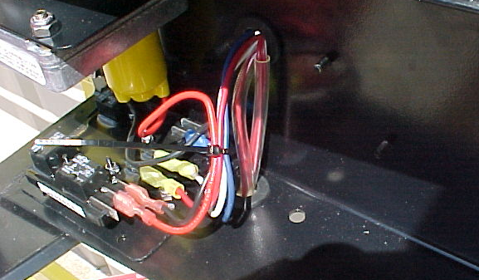
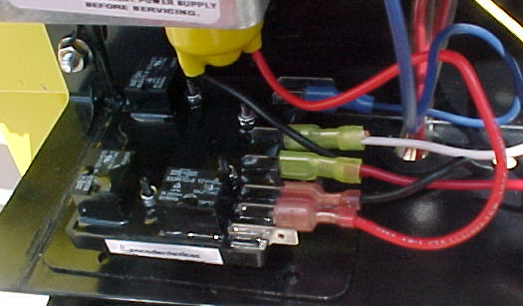

Drain hole

18. Secure lower hinge to camshaft with ¾ “ nut.
Timing mark
19. Tie wires. If unit does not have drain hole, add one.

17. Connect +12VDC & GROUND per schematic.

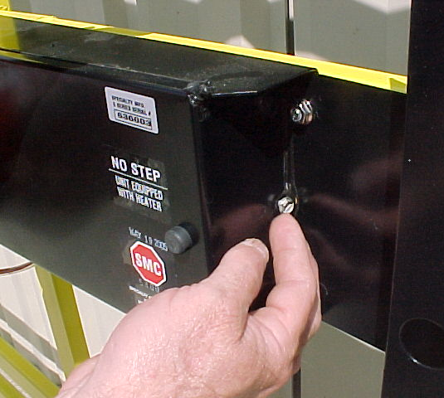
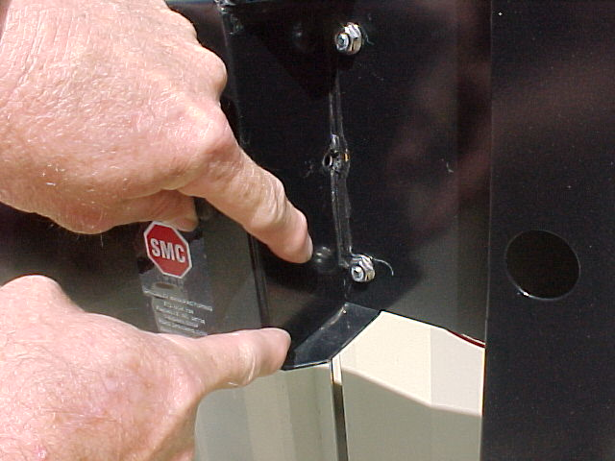
LEAVE THIS SECTION UNSEALED

21. Test the stop arm assembly to make sure it functions correctly. If further help is needed, contact the engineering department at Specialty Manufacturing.

20. Replace cover. Secure with (2) screws. Reseal both ends of the crossing arm cover with RTV.
IMPORTANT! - DO NOT seal approximately 1” of the lower right side of the box. This provides an additional drainage location.

