The Specialty Strobe lights (designated by 6-digit part numbers) must be wired with the correct polarity to function properly. The below diagram is provided to assist with the proper connection of this unit.

Check state and local regulations for mounting location of strobe light. For maximum visibility, mount strobe light at rear of bus, behind any roof hatches, ventilators, etc. which may decrease the visibility of the light.
Mount the rocker switch in a location easily viewable from the driver’s seat. Make the switch wiring connections according to the diagram below. Connect the power wire to a 5A fused source.

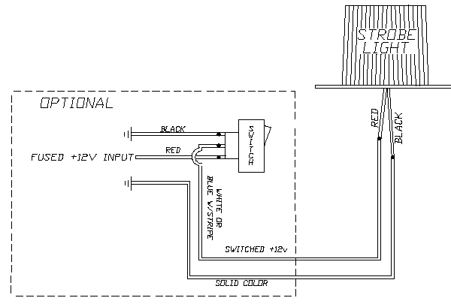
5A FUSED +12V /+24V INPUT

16 AWG wire

OPTIONAL SWITCH

*Note 1: All strobe lights must be wired with the correct polarity [RED+, BLACK-(Ground)] to function properly. It’s recommended that the power source supplied to the strobe light comes from a circuit that keeps the voltage reasonably stable insuring the line isn’t excessively noisy. A noisy power source can cause erratic operation of the strobe light. (Input voltage should be greater than 10 volts)

*Note 2: The weep hole (“REAR” (stamped in metal base)) of strobe light MUST be in back, away from normal air flow (direction of travel). DO NOT seal over the weep hole (drainage).

