On 8640 (A or B) and 8650 (A or B) model hatches with serial numbers prior to 214883, the interior red plastic handle can be turned both directions to open the latch. To modify the latch so that it only opens in one direction, the following is required: One Way Latch Conversion Kit # 8537, drill with 1/8” drill bit, and a phillips screwdriver. The latch conversion kit contains the following parts: 1 nylon plastic striker plate (8617) with VHB pre-applied tape, 3 decals (8718, 8548, 8549), and Technical Bulletin A202 (this document).

Step 1: Open inside handle latch and push hatch lid open. Remove and save micro-switch cover and micro-switch using phillips screwdriver. Remove the existing plastic striker by drilling small silver colored rivet heads. DO NOT drill through the rivets or through the back-side of the mounting frame (doing so will damage mounting frame and cause leaks). After plastic striker is removed, remove what is left of the two small rivets.

Step 2: Clean the surface of the plastic around the hole made by the small rivets. Orient the new plastic striker such that the locking detents on the striker are on the top and the solid section of the striker is on the left hand side (see figures 1 & 2). Remove protective sheets on the VHB pre-applied tape on the back side of the striker and insert striker into slot. Press firmly on both ends of the striker to fully seat VHB tape against the mounting frame. Replace micro-switch and micro-switch cover.

Step 3: Remove red decals “TURN HANDLE AND PUSH” and “OPEN FOR EMERGENCY USE ONLY” and replace with the two new RED decal as shown in figure 3. Attach BLACK arrow decal to top outside surface of hatch near outside handle.

Figure 1. After Conversion (Left View) Figure 2. After Conversion (Right View)
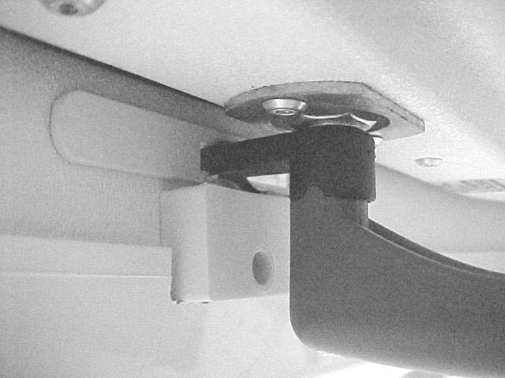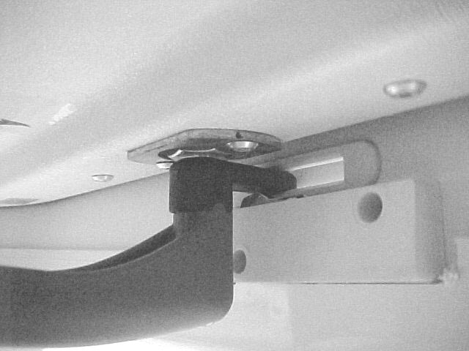

Figure 3. After Conversion (Bottom View)
