On 89xx series and 8645 model hatches with serial numbers prior to 206101, the interior red handle can be turned both directions to open the latch. To modify the latch so that it only opens in one direction, the following is required: One Way Latch Conversion Kit #8543 (for white hatches) or #8539 (for gray hatches) or #8540 (for beige hatches), Technical Bulletin A103 (this document), a phillips screwdriver, and a ¼” wrench.

The latch conversion kit contains the following parts:

1 plastic rear support (white 8956, gray 8813, or beige 8814) 4 screws (8963) 2 locknuts (5440)
4 decals (8718, 8542, 8548, 8549) 1 switch (8639) 2 springs (8993)

Step 1: Pop hatch lid up, open inside handle latch and push hatch lid open. Remove the existing plastic rear support by removing the 4 phillips head screws attaching it to the lid assembly. Insert the two anti-rattle springs into the holes on the new plastic rear support. IMPORTANT: Install the new rear support such that the smaller opening faces the handle. Replace 4 phillips head screws into the existing holes in the lid assembly. Test the handle to be sure it now only opens/closes in one direction. If it still opens/closes in both directions, remove the plastic rear support, rotate it 180° and reattach.

Step 2: If desired, replace micro-switch by removing two 4-40 locknuts on the micro-switch cover, remove cover and switch, replace with new micro-switch in same orientation on studs, replace cover. Use new 4-40 locknuts to secure cover. IMPORTANT: Do not over-tighten locknuts as damage to plastic switch may occur.

Step 3: Remove red decals “TURN HANDLE AND PUSH” and “OPEN FOR EMERGENCY USE ONLY” and replace with the two new red labels as shown in figure 2. Attach new white letter decal to the bottom of the black plate assembly as shown in figure 2. Attach black arrow decal to top outside surface of hatch near outside handle.

Figure 1. Before Conversion Figure 2. After Conversion
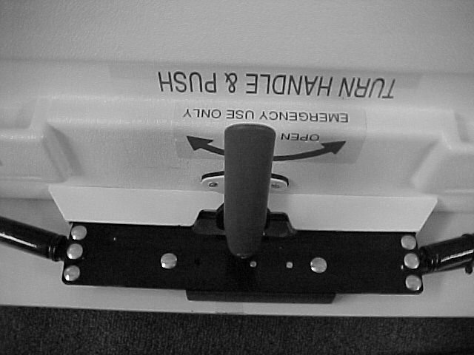

Wide opening (before) vs. narrow opening (after) on plastic rear support. The narrow opening allows handle motion in only one direction.

