The 6120 Modules with date code GK1 and later (see Figure 1 for top & left-side views) incorporate a one second time delay between the closed shutdown point and the actual motor shutdown.

The purpose of this is to guarantee the attached Crossing Gate (X/G) or Stop Arm (S/A) on the 6- Series units are properly nested against the stop fixture when mounted on a vehicle.

This means that operation of 6- Series unit without an attached X/G, S/A or complete top to bottom hinge assembly will possibly result in the hinge arm continuing to turn past the normal closure point and/or to oscillate at the ~ -90º position. If this happens, disconnect the power and manually swing the hinge arm to within the normal operating range before proceeding with the unit’s installation or test.

When connecting power source, make sure it is fused at 5 amps.

If further help is needed, contact the Engineering department at Specialty Manufacturing Company.

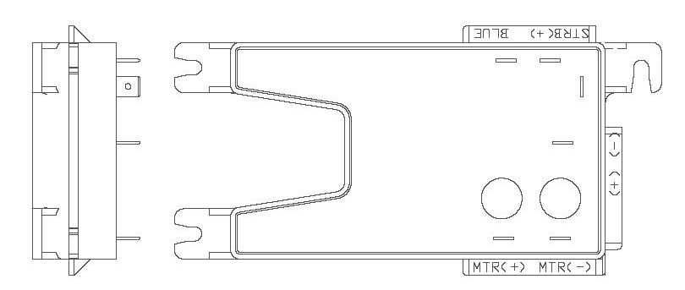
# 6120

FUSE AT 5A

Figure 1

