Effective November 1, 2010, Transpec multi colored hatches (differing interior and exterior colors) will be shipped with the exterior lid color “molded” into the plastic. Currently some hatches are produced with the exterior surfaces of the lid being painted to match a specific color. As is common with painted parts, careful handling is required to ensure a top quality appearance throughout the shipment, storage and installation processes. In an effort to continuously improve SMI’s family of products, the decision has been made to mold the necessary color into the plastic to provide a more durable finish. This will be a running change from the “painted” exteriors to the “molded” exteriors based on inventory levels.

The affected hatches include:

* T1077 Dual Purpose Dark Gray Interior with a White Exterior
* T1078 Dual Purpose Light Gray Interior with a Dark Gray Exterior
* T1079 Dual Purpose Beige (Sand) with a White Exterior
* T1177 Triple Value Dark Gray Interior with a White Exterior
* T1677 Power Vent Dark Gray Interior with a White Exterior
* T1679 Power Vent Beige (Sand) with a White Exterior
* T1977 Standard Dark Gray Interior with a White Exterior
* T2077 Motorized Dark Gray Interior with a White Exterior

This change does not affect the T1073, T1074, or T2073 hatches.

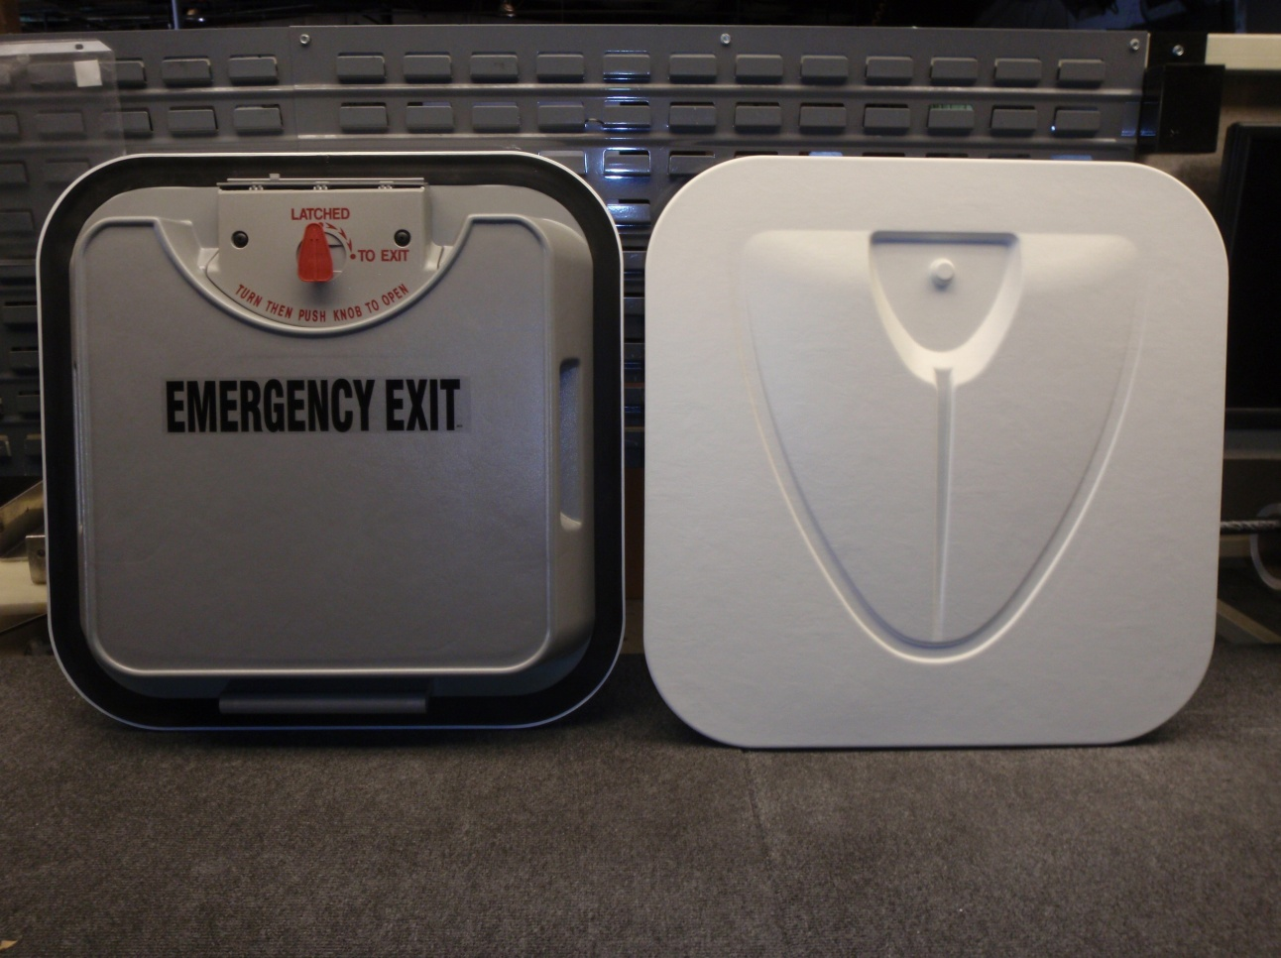

Molded Interior- Dark Gray

Molded Exterior- White