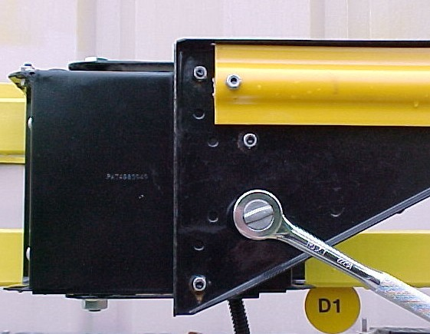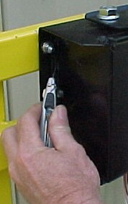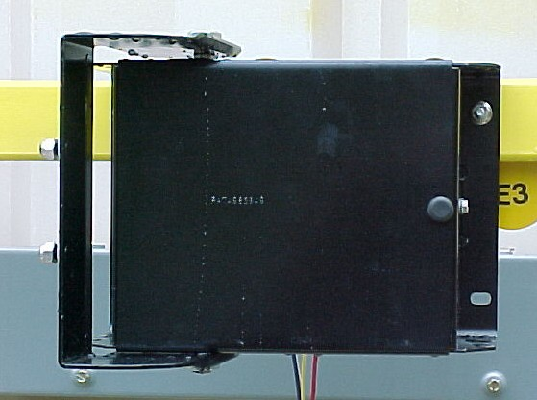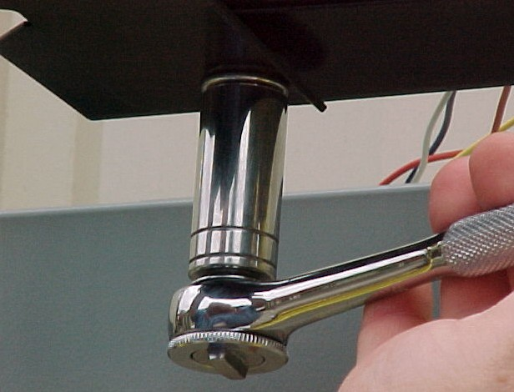
4. Remove ½-20 nut @ bottom of hinge w/ ¾” wrench. Discard it.
1.Remove (4) ¼-20 nuts with 7/16” wrench & remove arm.
2. Cut seal at both ends of cover.
3.Open hinge to 90° or past for access to unit.
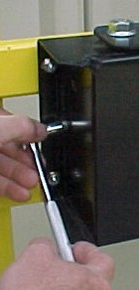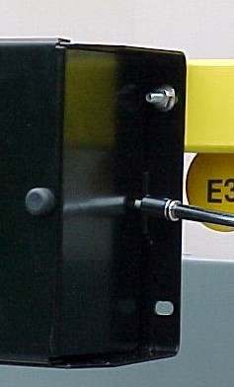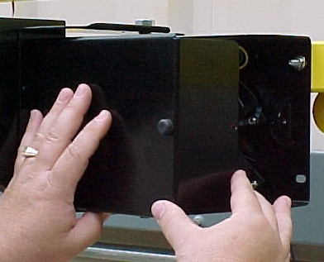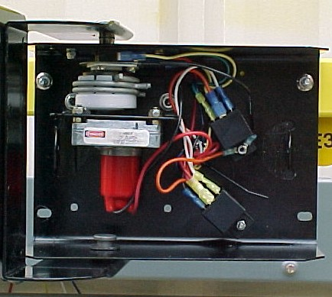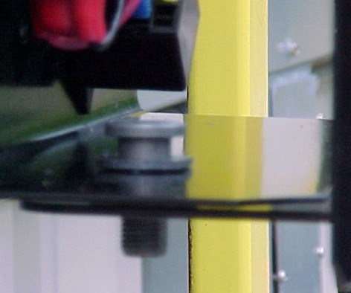
8. Tap hinge pin into box from bottom.
5. Remove screws from both ends of cover w/ 5/16” wrench.
6. Remove cover and set aside.
7. Inside view of control box.

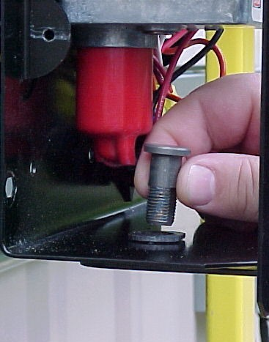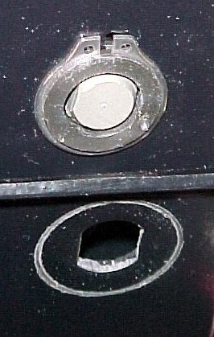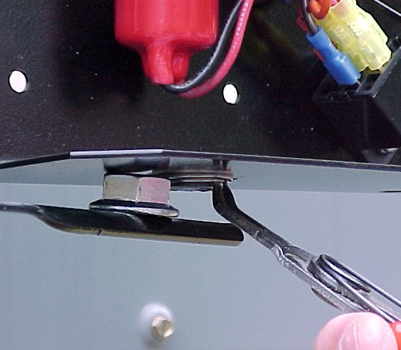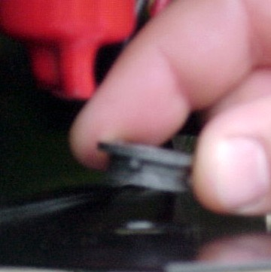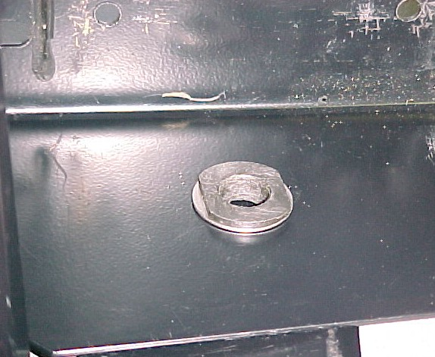
Tab

Washer

Bushing
9. Remove hinge pin. Discard.
10. Carefully move hinge away to access bottom spring clip & remove. Hinge may be shimmed for easier access.
11. Remove plastic bushing w/tab from inside. Discard
12. Install new ¾” SST washer & plastic bushing inside box.

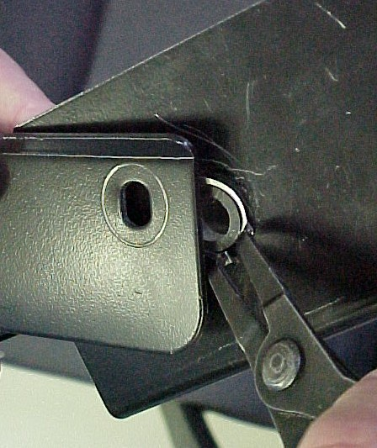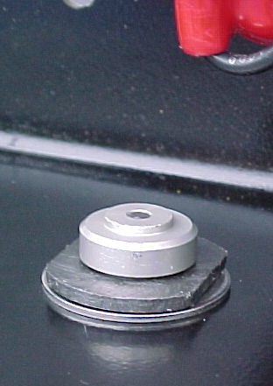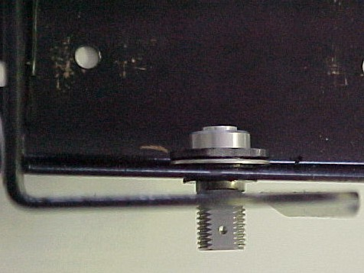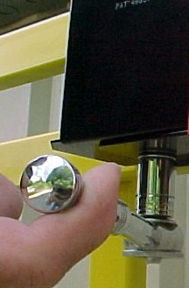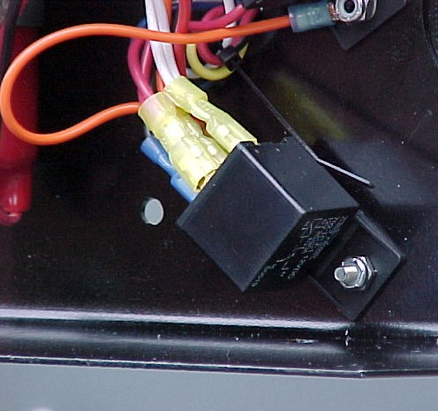
Timing Mark

Shaft
15. Install new shaft (replaces old hinge pin) w/timing mark oriented the same direction as hinge. (Ex.: If hinge is opened to 90° timing mark should be pointing away from the side of bus.
16. Install new ½-20 hex lock nut.

17. Remove 10-32 nuts on both relays. Discard nuts. Slide relay’s off studs.
Remove
13. Install new spring clip in plastic bushing groove.
14. Close-up of
shaft, bushing & washer installed.

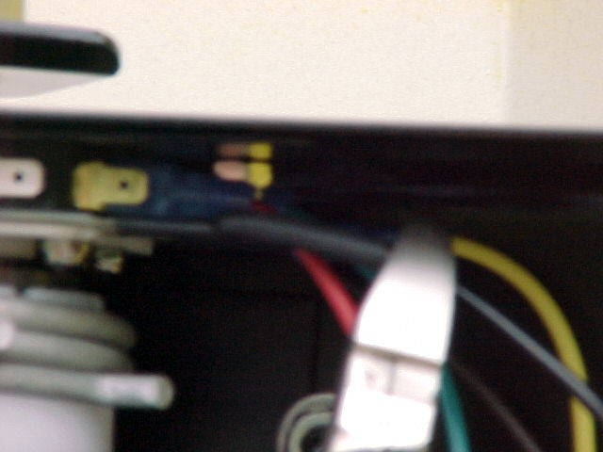
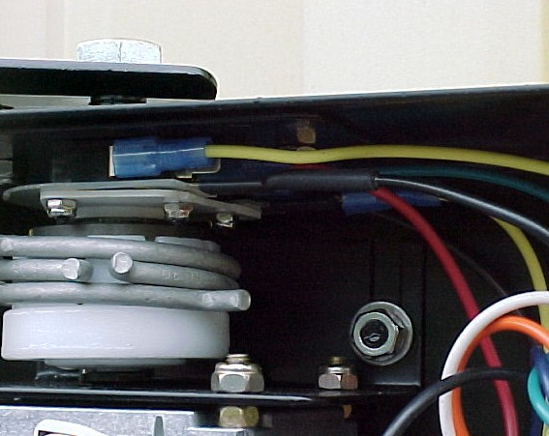
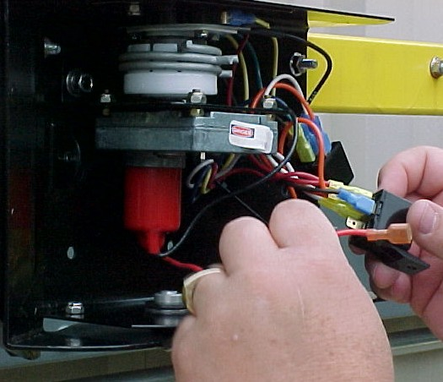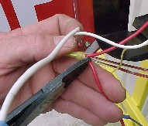
20. Remove yellow, brown & green from rear micro-switch; yellow & red from front switch. Discard relays.
21. Cut black wire from heater in micro-switch assy at end of shrink-wrap. Discard. Tape end of yellow wire from bus.

Align with holes in back of box.
18. Disconnect -double red, single red & double white from lower relay; -double blue/green & black from upper relay.

19. Cut short red wire from double red, short white from double white & short green from double blue/green. Discard cut wires.

1. Remove (4) 1/4-20 nuts & remove arm.
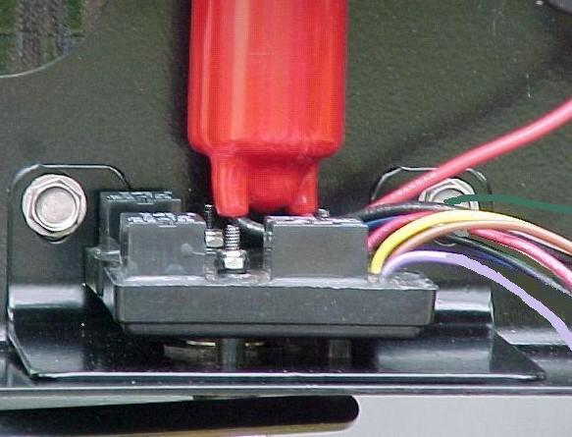
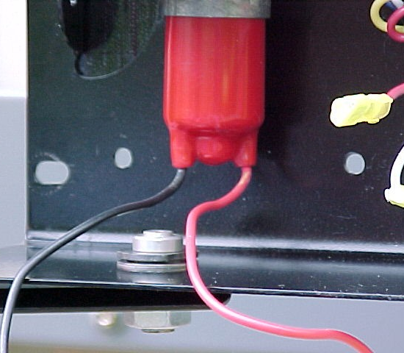
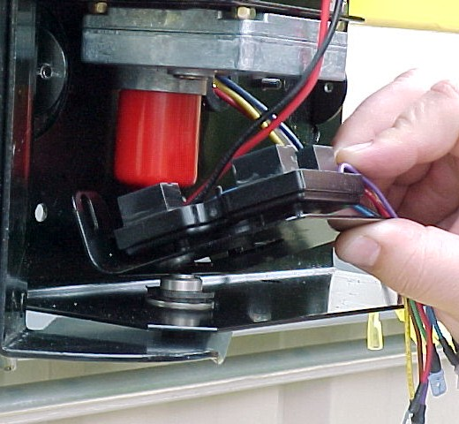
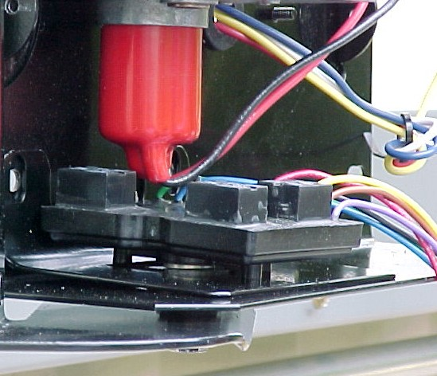
23. Hold motor wires. Insert module assembly at an angle to clear motor.
24. Set module on shaft - rotate bushing as reqd for module to set evenly. Align w/holes in box. (Drill 9/32 hole if mntg. brkt. interferes.)
25. Attach module with ¼-20 screws, flat & lock washers and hex nuts included in kit.
Align with holes in back of box.
22. Area below motor where sentinel module will be installed.

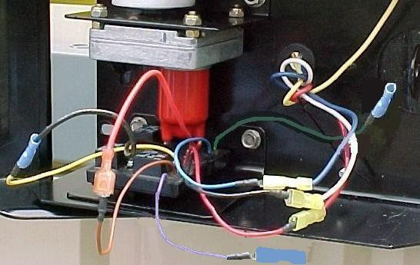
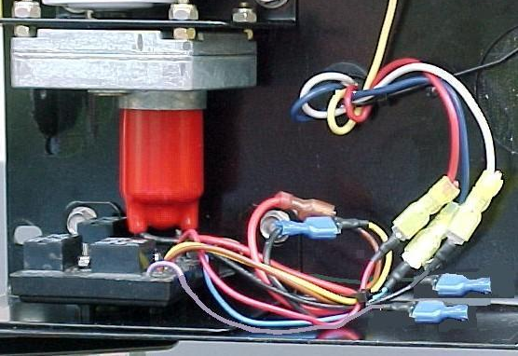
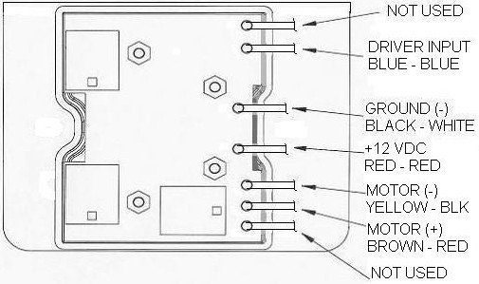
26. Wiring schematic. View looking down on top of module.
(Left is passenger side of bus, bottom is front of bus)
27. Connect wires as shown above
& in schematic #26. Tape each lead connection to insulate male tab on module leads. Tape end of yellow wire from bus to insulate & tie back.
Yellow wire from bus.
28. Tie wires. View of completed internal installation. Note: Purple & green wires from module not used – insulate & tie with other wires –do not remove female terminals installed on ends.
Tape each lead connection.
Leave female terminals on purple & green.

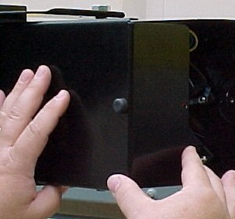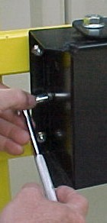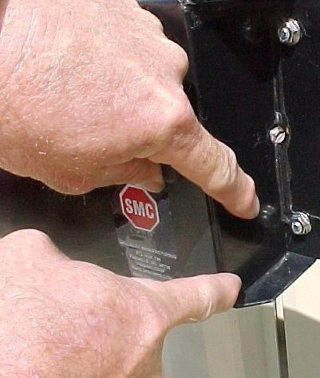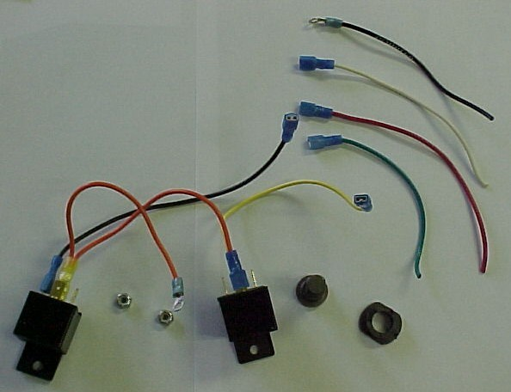
Leave these UNSEALED
29. Replace cover.
30. Re-install screws at both ends. Re-seal w/black silicone leaving bottom & ½” on bottom side open for drainage.
31. Re-attach arm.
32. Items to be discarded.
33. Test the crossing arm assembly to make sure it functions correctly. If further help is needed, contact the engineering department at Specialty Manufacturing.

