
ISO 9001:2000 Registered
TECHNICAL BULLETIN - #A002 Page 1 of 3
SUBJECT: TROUBLESHOOTING 6-SERIES UNITS
Effective Date: 2/10/00 Revised Date: 8/19/05

The 6-series stop arm & crossing arm contains two internal circuits; a motor circuit and a motor control circuit. The motor control circuit is a solid-state hall-effect, encapsulated module that senses the position of the arm and energizes the motor according to the control signal from the 4 or 8 light flasher system. When the 4 or 8 light flasher system is ON and the door is opened, the ‘Stop Arm Solenoid’ terminal on the flasher system provides a signal (+12V) to the solid-state control module via the Blue Wire. The control module provides the proper voltage and polarity for the motor to move the hinge and attached arm to the OPEN position. When this signal is 0 volts, (door closed and lights off), the control module provides the proper voltage and polarity to return the hinge and attached arm to the closed position. The vane attached to the drive shaft is shaped to sense the position of the hinge in relation to the status of the control signal and to start or stop the motor action accordingly. The 6-series unit is internally grounded through the white, eliminating the possibility of faulty external chassis grounds.

While it may seem complicated, the 6-series may be easily troubleshot using a test light or DC voltmeter. Please refer to the appropriate wiring diagram for the reference points listed.
*Note: components that are determined to be ‘at fault’ are not necessarily defective. The fault may be due to loose connections and/or improper operating voltage. The situations listed below are those that may be encountered in the field. If further help is needed, contact the engineering department at Specialty Manufacturing.

- Unit is switched ON, 4 or 8-light flasher system is ON and the door is open causing the lights at the top of the bus to switch from Amber to Red, but the unit will not open:

  - Pull the hinge fully open, remove the cover and then partially close the hinge. Check for voltage at (A). The voltage should be 12V. If not, then check for a steady 12V at the “Stop Arm Solenoid” terminal on the 4 or 8 light flasher system. If this is not 12V, then the flasher system or wiring connections are ‘at fault’. If the voltage at these two points is 12V then proceed to step 2.

  - Check the voltage at (B). If this voltage is NOT 12V, the power source on the bus is ‘at fault’. Verify the associated fuse or circuit breaker is okay. If this voltage is acceptable, proceed to step 3.

  - Check for a chassis ground at (E). If no ground is found, check the connection of the white wire inside the bus. If this chassis ground connection is okay, proceed to step 4.

  - Remove the Black and Red motor wires and check the voltage across the terminals at (C) and (D). If this voltage is NOT the recommended (0V and +12V to OPEN) or (+12V and 0V to CLOSE), the module is probably ‘at fault’. If this voltage checks out, the motor is probably ‘at fault’. The motor can be verified faulty by touching the Black and Red wire terminals across a known good 12-volt voltage supply such as a battery or the live bussbar and ground. If the motor runs during this touch check, the terminals crimped onto these wires may be ‘at fault’ or one of these wires may be shorted to the motor casing and gearbox.

- Unit is switched ON, opens to 95+ degrees or excessively past 90 degrees:

  - This is most often due to the vane being out of position on the clutch shaft. The small hole of the vane should ~line up with the left top edge of the module body. For proper operation, the vane is nested onto two shaft flats angled to each other and held in place with a nut and lockwasher and may be corrected if it is loose or has slipped out of position.
See diagrams below of proper vane location in module.
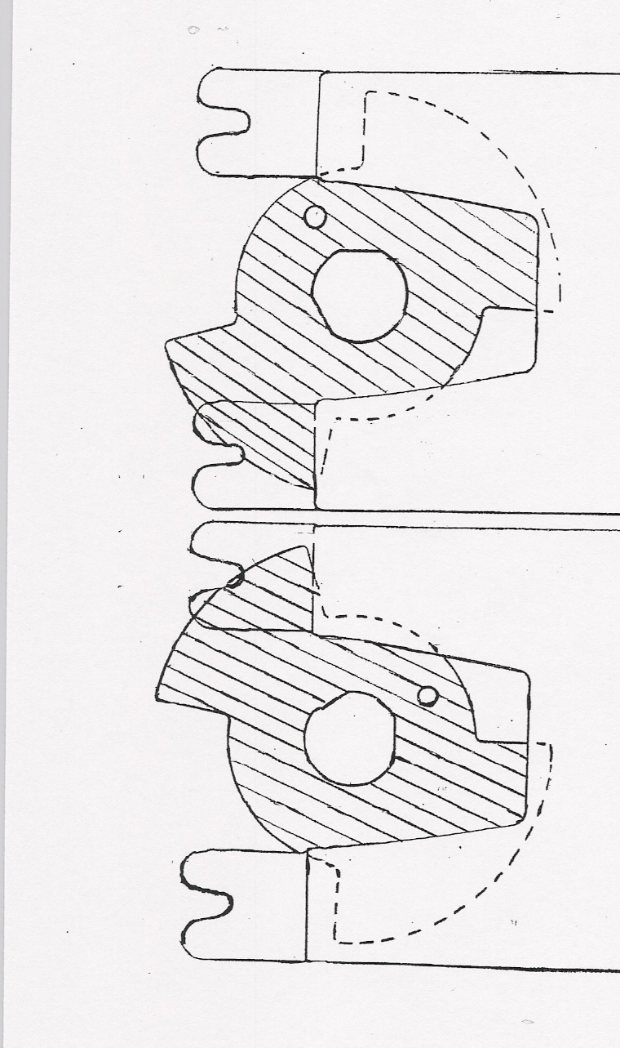
module

vane

Vane location with unit OPEN Vane location with unit CLOSED
Note location of punched hole in vane. Note location of punched hole in vane

- Unit is switched ON, opens to ~90 degrees and closes when switched OFF, but will not return to the OPEN position if pushed way past the 90 degree position.

  - This is most often due to the module being ‘at fault’.

Motor is running but Unit does not open
  - Verify RotoClip clamps are intact. If RotoClips are broken or worn, the clutch may be slipping- replace RotoClips. (p/n 5030)
  - Verify shaft of motor is turning. If the shaft is not turning but the motor can be heard running, then the motor is bad. Replace motor with p/n 5013.

- Unit operates properly, but continues to run after closing.
  - This is most often due to the vane being out of position on the clutch shaft. The small hole of the vane should ~line up with the left edge of the module body at the 90 degree position and the top right edge of the vane lobe should ~line up with the left top edge of the module at the closed position. For proper operation, the vane is nested onto two shaft flats angled to each other and held in place with a nut and lock-washer and may be corrected if it is loose or has slipped out of position. (see diagrams of vane location in section B)
  - The crossing arm rod and bracket may be bent. The unit will continue to run if the arm is bent and the rod touches the bumper before the module senses the “closed” position.

  - *Note- Modules with 2 cylindrical capacitors protruding out of the epoxy near the terminals are designed to keep the motor running for ~1 second after sensing the closed position to ensure the blade or gate is against the bus body or bumper.

- Unit is switched ON, opens properly, but will not close after being switched OFF (door closed).

  - Pull the hinge fully open, remove the cover and then partially close the hinge. Check for voltage at (A) to 0 volts. If this voltage is NOT 0V, check the voltage at the “Stop Arm Solenoid” terminal on the 4 or 8 light flasher system for a proper input signal of 0 volts. The flasher system or the wiring connections to the unit may be ‘at fault’. If the voltage at these points checks out, proceed to step 2.

  - Remove the Black and Red motor wires and check the voltage across the terminals at (C) and (D). If this voltage is NOT within the guidelines (0V and +12V to OPEN) or (+12V and 0V to CLOSE, the module is probably ‘at fault’. If this voltage checks out, the Motor is probably ‘at fault’. The Motor can be verified faulty by touching the Black and Red wire terminals across a known GOOD 12 volt voltage supply such as a battery or the live bussbar and ground. If the Motor runs during this touch check, the terminals crimped onto these wires may be ‘at fault’ or one of these wires may be shorted to the motor casing and gearbox.

  - Verify ground connections: Check ground from white wire to chassis ground on motor at orange wire. If it’s bad- run a ground wire from chassis to base of unit.

  - Verify RotoClip clamps are intact. If RotoClips are broken- replace RotoClips. (p/n 5030)

- Unit is switched ON, opens properly, but moves back and forth about 3 to 4 inches on the blade tip, commonly called “oscillation”.
-or-

Optional Strobe Light either operates erratically or not at all. The Voltage at the blue
wire is below 12 volts (A).

  - This is typically caused by the signal voltage from the 4 or 8 light flasher NOT being steady or by a low voltage condition originating with the 4 or 8 light flasher NOT supplying enough source voltage to run the lighting system, especially in cold weather environments where the temperature drops close to or below freezing causing the reduced voltage condition. See SMC Technical Bulletin #A001 for complete details on how to correct this problem.

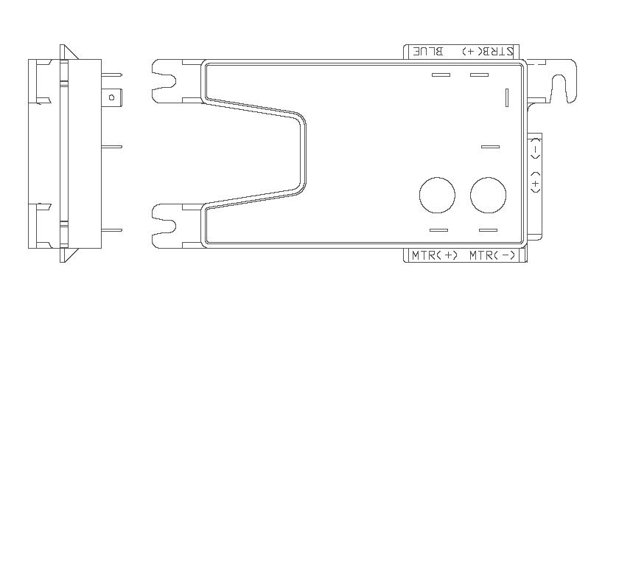
(Optional)
To 4 or 8 light Flasher
BLUE (A) RED To Strobe Power Pack

BLUE

+ (E)

WHITE & BLACK
WHITE
To
RED Chassis
Ground and To
Strobe
(B) Power
Pack
(Optional)
MTR + MTR -

RED: TO FUSED +12v

(C) (D)
RED
MOTOR
BLACK

