

**Specialty Manufacturing, Inc.  
  
Technical Bulletin**

**SA7-0001-00**

**Replacement Procedure for**

**6&7-Series Vane**

**This manual contains proprietary information of SMI. It is intended solely for the information and use of parties operating and maintaining the equipment described herein. Such proprietary information may not be used, reproduced, or disclosed to any other parties for any other purpose without the expressed written permission of SMI.**

**Purpose**: This technical bulletin provides information regarding replacement of the clutch vane for 6&7-Series Stop Arms and Cross Arms to address non-factory alignment issues to address continuous running motors.

Note: This does not apply to units with build dates after 03/11/2013

**Contents of the kit (SMI part number 007013-7K):**

* Position vane.
* Clutch pin.

**Procedure:**

1. Disconnect power to stop arm.
2. Remove stop arm from bus.
3. Manually open stop arm to 90° (open position) for ease of disassembly.
4. Remove 2 screws from stop arm cover and remove stop arm cover.

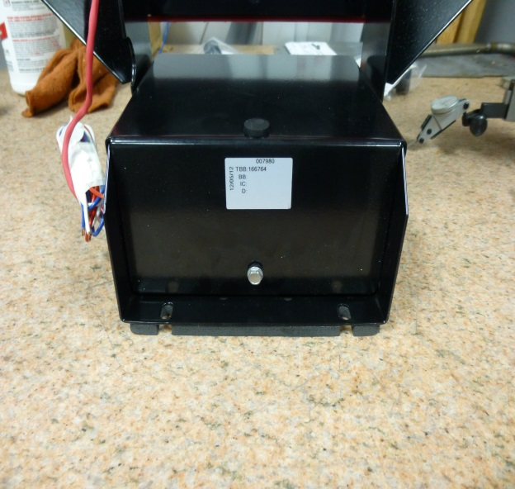 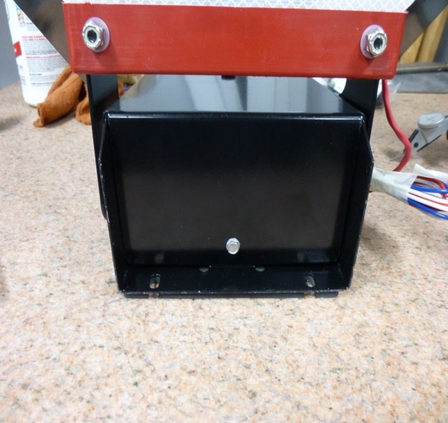

1. Carefully pull wiring harnesses from stowed position.

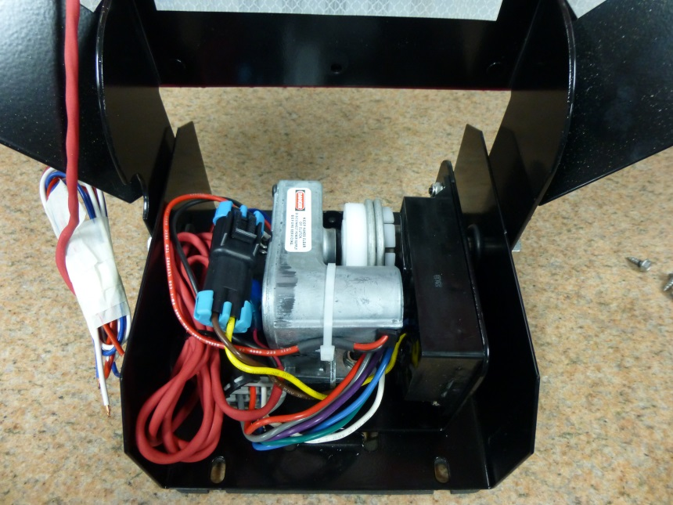

1. Remove 3 nuts from L-bracket base.

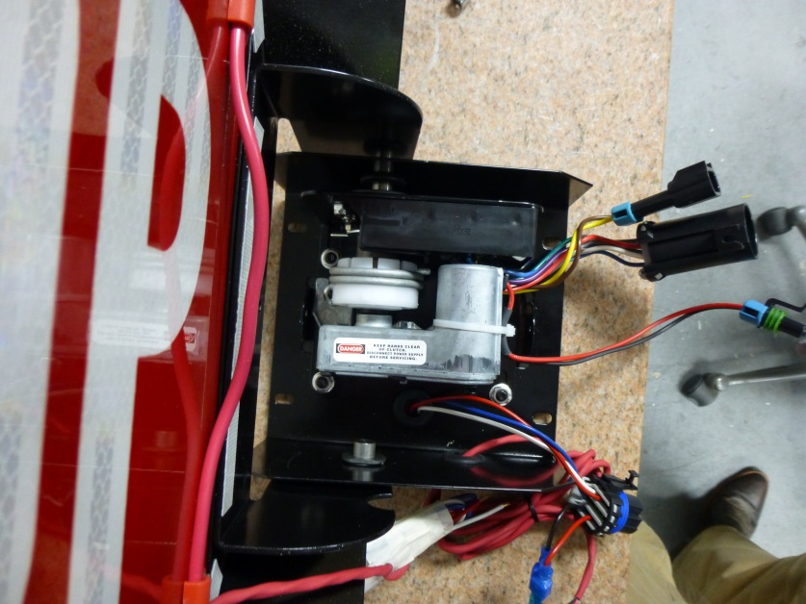

1. Remove nut from blade bracket on both sides of unit.

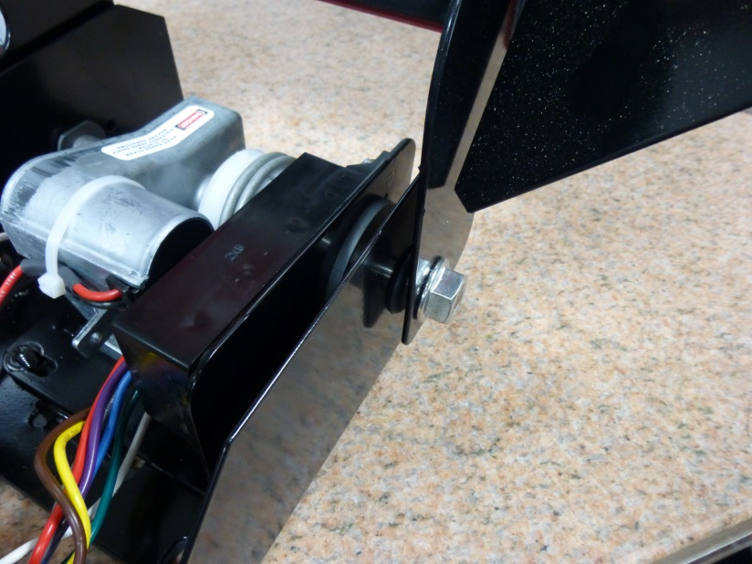

1. Remove floating pin from blade bracket for easier disassembly.
2. Slide L-bracket out of stop arm base.
3. Remove 2 nuts from motor mounting studs and remove motor.

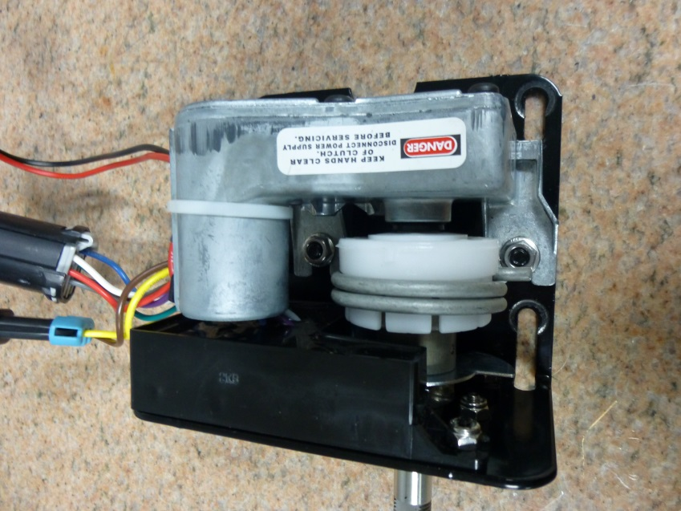

1. Loosen 3 nuts on module mounting studs and remove module.

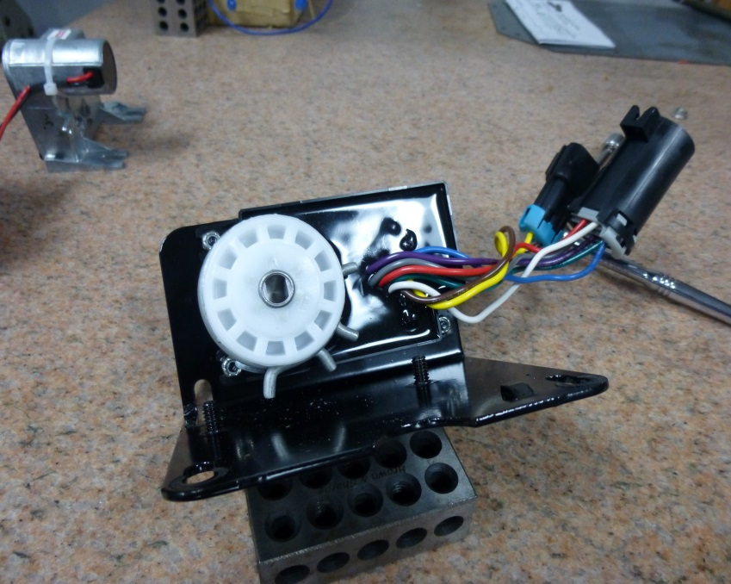

1. Remove clutch assembly.
2. Note the position of small lobe, large lobe, and indicator hole.

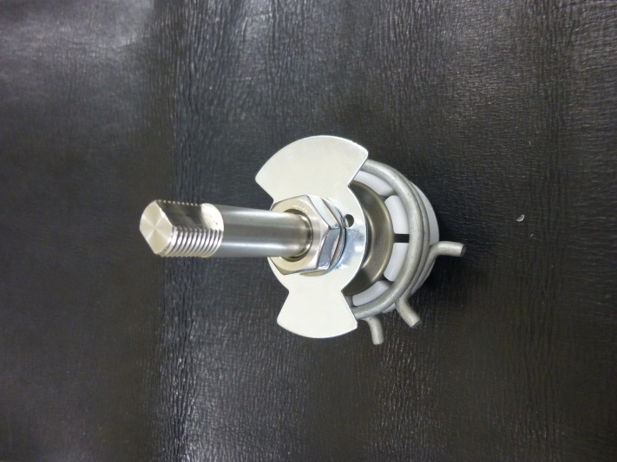

**LARGE**

**SMALL**

**HOLE**

1. Mark the large lobe and corresponding side of the shaft.

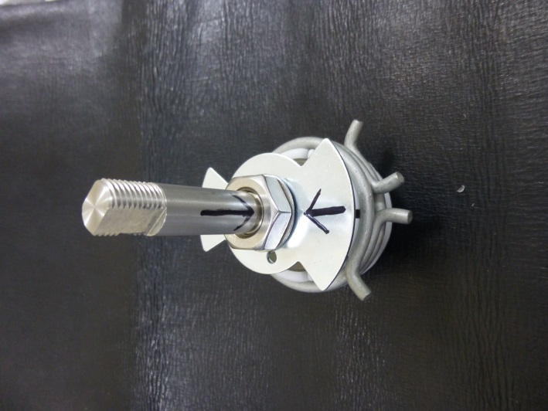

1. Secure clutch pin (included in kit) in vise. Set clutch on pin and remove main retention nut and lock washer. **(Need picture)**
2. Remove old position vane.
3. Note that the small lobe is SMALLER on the new vane.

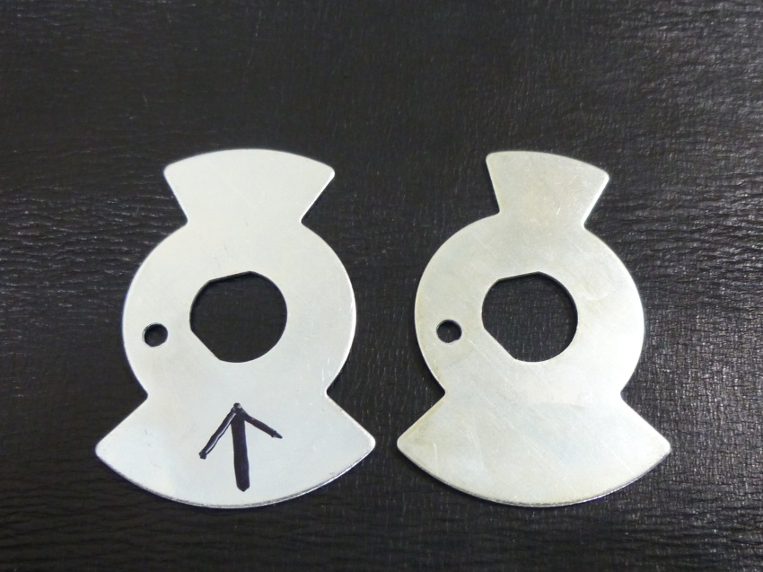

**NEW**

**OLD**

1. Mark large lobe on new vane.

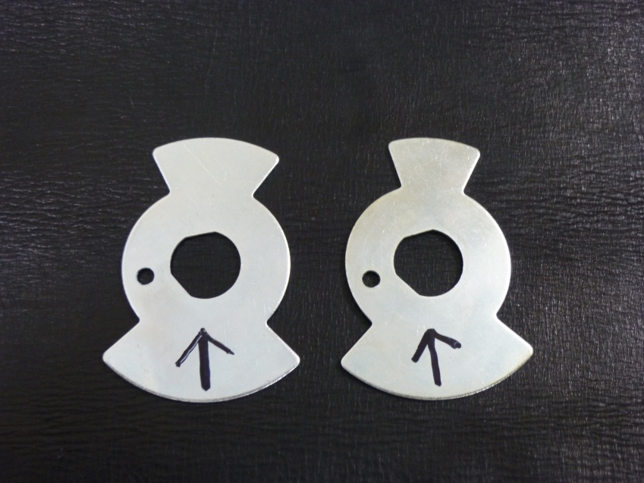

1. Place new vane on the clutch assembly, making sure that the lobe mark corresponds to the mark on the shaft.
2. Replace the lock washer and nut.
3. Make sure the clutch assembly is seated fully on the clutch pin.
4. Tighten the main retention nut until the clutch begins to slip (~150 in/lb of torque). **(Need picture)**
5. Reassemble L-brackett assembly. Verify that there is no interference between the vane and the module.
6. Make sure the orientation of the clutch matches the photo. Note the position of the hole and the small lobe. This position corresponds to the blade at 90° (open) position.

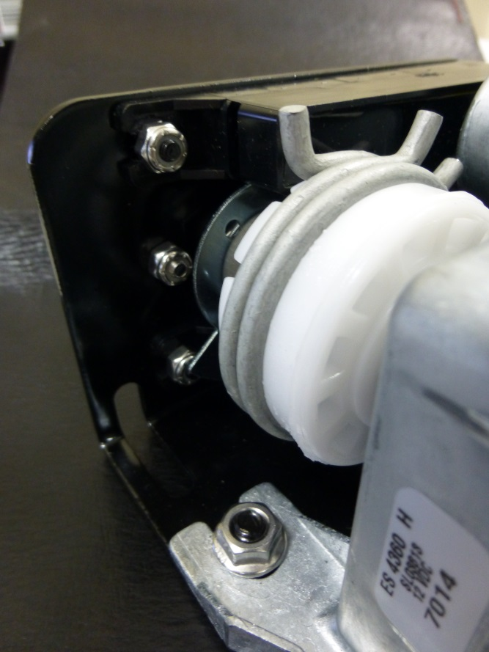

**SMALL**

**HOLE**

1. Reassemble the full stop arm assembly. Carefully stow the wiring harnesses in the original position to prevent wiring damage before replacing the outer case.



1. Reinstall stop arm on bus and reconnect power.

|  |  |  |  |  |
| --- | --- | --- | --- | --- |
| **Rev.**  **Level** | **Rev.**  **Date** | **Details** | | **Description of Change** |
| **Page** | **Para.** |
| - | 04/12/13 | ALL | ALL | INITIAL RELEASE |
|  |  |  |  |  |
|  |  |  |  |  |
|  |  |  |  |  |

Specialty Manufacturing Group, Inc.  
10200 Pineville Rd  
Pineville, NC 28134  
Toll Free 800-951-STOP (7867)  
Phone 704-889-7518  
Fax 704-889-2760

[http://www.smiglobal.net](http://www.smiglobal.net/)

For Technical Support, Email: [tech.support@smiglobal.net](mailto:tech.support@smiglobal.net)

More technical publications available at:

http://www.smiglobal.net/tech_bulletins.php