**VERTICAL ALIGNMENT OF INTRGRATED ARMS THAT FALL BELOW MAGNET IN CLOSED POSITION:**

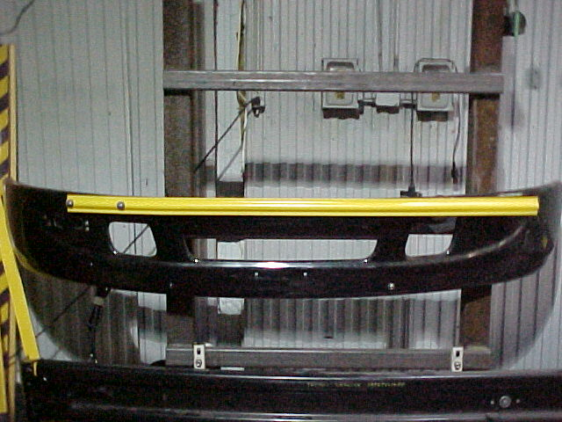

Magnet

1.) Crossing arm will be in the fully closed position and the arm will fall below the magnet or be above it.

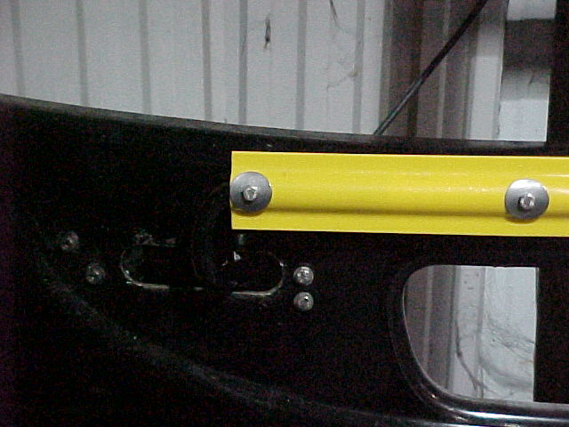

Bolts

2.) Remove plastic splash cover behind the bumper.

Loosen the four bolts shown above and align control

until arm is level & contacts the magnet. Re – tighten

the four bolts evenly torque to 10 ft. lbs. Install plastic cover.

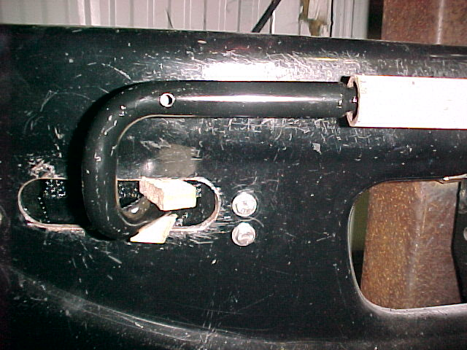

Wedges

3.) If aligning the control unit does not bring arm into

alignment (contact with magnet) remove yellow – poly rod

& set aside. Install suitable wedges above & below arm

Protruding through slot in bumper.

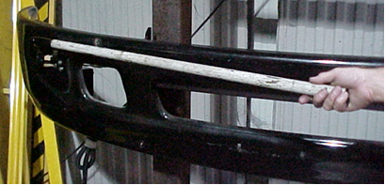

4.) Slide a pipe over the arm protruding through the slot in the bumper and push up or done

slightly as required. Fit yellow poly rod over to see if aligned & contacting magnet. If arm

is in position install ¼ - 28 bolts and formed washers. If arm is still out of – line, remove yellow

poly rod and bend again slightly using the pipe. Install yellow poly rod.

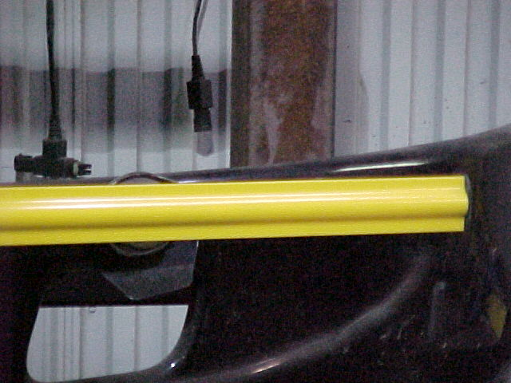

Magnet aligned with yellow poly rod

Safe Fleet Bus & Rail

13501 South Ridge Drive

Charlotte, NC 28273

Toll Free: 800-951-STOP (7867)

Phone: 704-247-9300

Fax: 980-216-4606

[www.safefleet.net](http://www.safefleet.net)

For Technical Support, Email: [ncTechSupport@safefleet.net](mailto:ncTechSupport@safefleet.net)

More technical publications available at: <https://busandrail.safefleet.net/resources/technical-bulletins/>

This manual contains proprietary information of Safe Fleet. It is intended solely for the information and use of parties operating and maintaining the equipment described herein. Such proprietary information may not be used, reproduced, or disclosed to any other parties for any other purpose without the expressed written permission of Safe Fleet. Controlled copies of Safe Fleet documents are maintained within Safe Fleet. Printed or electronic copies in other storage locations are uncontrolled.