FOR INTEGRATED CROSSING ARMS THAT CONTINUE TO RUN WHEN IN THE CLOSED POSITION:

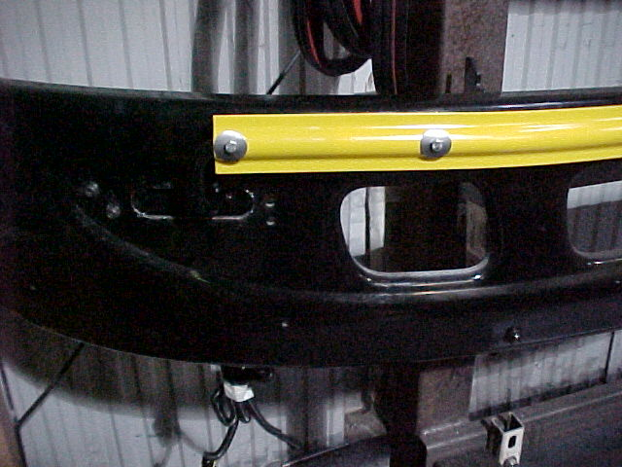

1.) THE CROSSING ARM WILL BE IN THE

FULLY CLOSED POSITION AS SHOWN IN

PHOTO TO LEFT, BUT THE UNIT WILL

CONTINUE TO RUN.

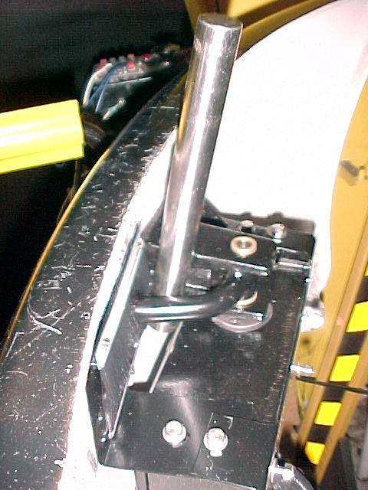

2.) PULL THE ARM INTO THE OPEN POSITION

AND PUT A BAR BEHIND THE BUMPER AND

THROUGH THE BEND IN ARM AS SHOWN TO

THE RIGHT.

OPEN

POSITION

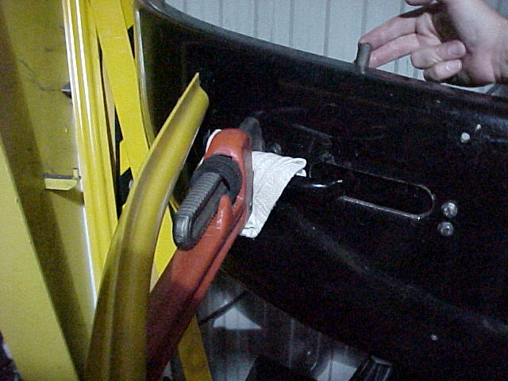

MOVE PRY BAR TO **LEFT**-



3.) USING A SUITABLE PRY BAR

– PLACE IT BEHIND THE ARM

PROTRUDING THROUGH

HOLE IN FRONT OF BUMPER

AND PUSH BAR TO

LEFT-SLIGHTLY TO

RE-BEND ARM.

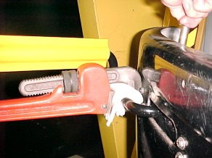

NOTE: Pry bar is BEHIND the crossing arm!

**FOR INTEGRATED CROSSING ARMS THAT CONTINUE TO RUN WHEN IN THE OPEN POSITION:**

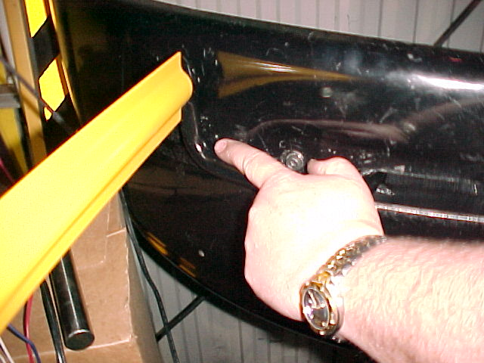

ARM HITS

BUMPER

1.) THE CROSSING ARM WILL BE IN THE FULLY

OPEN POSITION AS SHOWN IN PHOTO ABOVE

.THE ARM WILL HIT THE BUMPER AND

CONTINUE TO RUN.

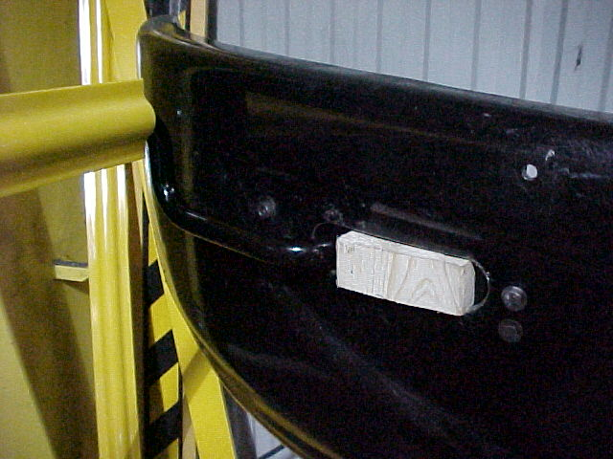

WEDGE

WEDGE

WEDGE

WEDGE

WEDGE

WEDGE

2.) WITH ARM IN OPEN POSITION - PLACE A SUITABLE WEDGE IN-BETWEEN THE ARM & THE EDGE OF THE BUMPER HOLE AS SHOWN TO THE LEFT.

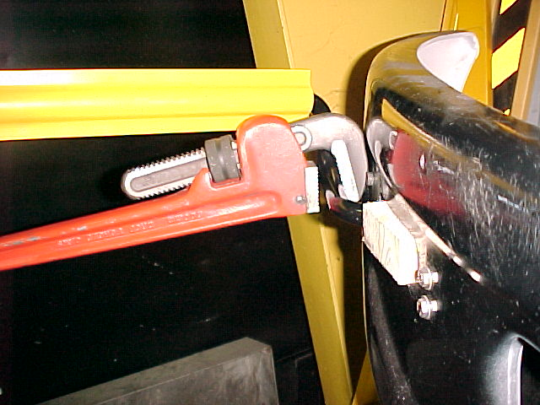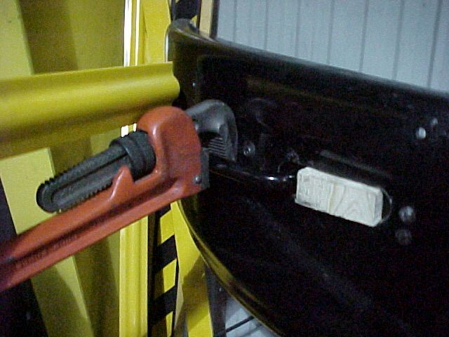

**NOTE: Pry bar is BEHIND the**

**Crossing arm!**

NOTE: Pry bar is BEHIND the crossing arm!

3.) USING A SUITABLE PRY BAR – PLACE IT BEHIND THE ARM PROTRUDING THROUGH HOLE IN FRONT OF BUMPER & PUSH BAR TO **RIGHT** – TOWARD RIGHT END (DRIVER’S END) OF BUMPER SLIGHTLY TO RE – BEND ARM.

NOTE: Pry bar is BEHIND the crossing arm!

Safe Fleet Bus & Rail

13501 South Ridge Drive

Charlotte, NC 28273

Toll Free: 800-951-STOP (7867)

Phone: 704-247-9300

Fax: 980-216-4606

[www.safefleet.net](http://www.safefleet.net)

For Technical Support, Email: [ncTechSupport@safefleet.net](mailto:ncTechSupport@safefleet.net)

More technical publications available at: <https://busandrail.safefleet.net/resources/technical-bulletins/>

This manual contains proprietary information of Safe Fleet. It is intended solely for the information and use of parties operating and maintaining the equipment described herein. Such proprietary information may not be used, reproduced, or disclosed to any other parties for any other purpose without the expressed written permission of Safe Fleet. Controlled copies of Safe Fleet documents are maintained within Safe Fleet. Printed or electronic copies in other storage locations are uncontrolled.